**INFO-I590: DATA VISUALIZATION (TOPICS IN INFORMATICS)**

**EV ADOPTION REGISTERED THROUGH WASHINGTON STATE**

**Team Visionaries:**

Prachi Jethava

Shalini Cherukuri

Yudheksha Kavitha

Sai Srinidhi Karanam

Kundhana Harshitha Paruchuru

1. **INTRODUCTION**

**1.1 Motivation**

In recent years, the global shift toward clean energy and sustainability has placed electric vehicles (EVs) at the center of innovation and policy reform. The transition to electric vehicles (EVs) is a critical part of global strategies to combat climate change, reduce greenhouse gas emissions, and move toward a more sustainable transportation future. Visualizing EV data helps **stakeholders** — **including policymakers, planners, businesses, and citizens** to identify areas needing infrastructure support such as charging stations, guide policy and investment decisions based on real-world trends.

For this project, our team wanted to explore not just a large dataset, but one with real-world impact—and Washington State’s EV population data stood out as the perfect candidate.

Washington consistently ranks among the top states for EV ownership per capita, supported by environmentally conscious consumers, progressive policies, and growing infrastructure. **The state has set ambitious goals to reduce vehicle emissions by 35% by 2026 and 68% by 2030, alongside a planned ban on the sale and registration of most non-electric vehicles starting with model year 2030 as per NBC.** These initiatives place Washington at the forefront of the transition to electric mobility in the U.S. What makes the state particularly compelling for study is its geographic and demographic diversity ranging from dense urban areas like Seattle to rural regions with distinct infrastructure challenges. This diversity offers valuable insight into how EV adoption patterns and needs vary across different communities.

Our **primary goal** is to analyze how electric vehicles are distributed across counties, how consumer preferences vary between battery electric vehicles (BEVs) and plug-in hybrids (PHEVs), and how vehicle cost and electric range influence adoption. With a dataset covering over 230,000 EV registrations, we aim to transform raw data into meaningful insights whether that’s identifying which counties lead adoption, uncovering market share by vehicle make and model, or visualizing the shift in public interest toward cleaner technology.

By focusing on Washington’s EV data, we hope to support smarter planning for infrastructure, policymaking, and future research—ultimately contributing to a better understanding of how electric mobility is unfolding in the U.S.

**I.2 Existing Work**

**I.2.1 Electric Vehicle Analysis – Harshit Raizada (Kaggle)**

**Resource Description:**This Kaggle notebook explores the Washington State EV population dataset using basic data cleaning and visualization techniques. It helps identify trends in electric vehicle growth, popular car models, and technology adoption over time using accessible and easy-to-read graphs.

**Effectiveness and Techniques:**

* **Bar chart**

This bar chart shows how EV registrations have increased over time based on vehicle model years. The number of EVs starts rising from 2011 and grows sharply from 2018 onward, with 2022 having the highest count. This trend highlights the rapid acceleration of EV adoption in recent years.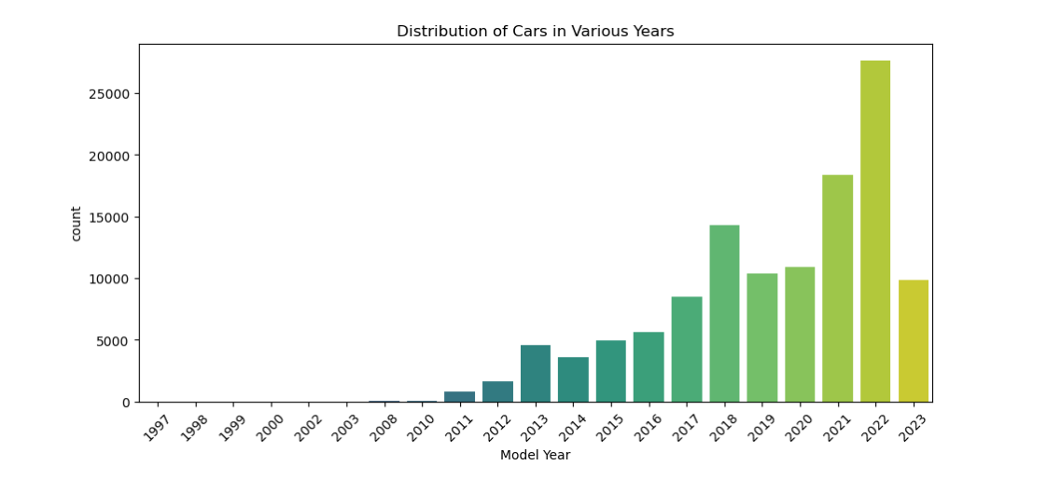

* **Pie Chart**

This pie chart illustrates the market share of the top 15 EV brands in Washington. Tesla dominates with over 51% of the EV fleet, followed by Nissan, Chevrolet, and Ford. The chart gives a quick and clear idea of brand dominance in the state's EV market.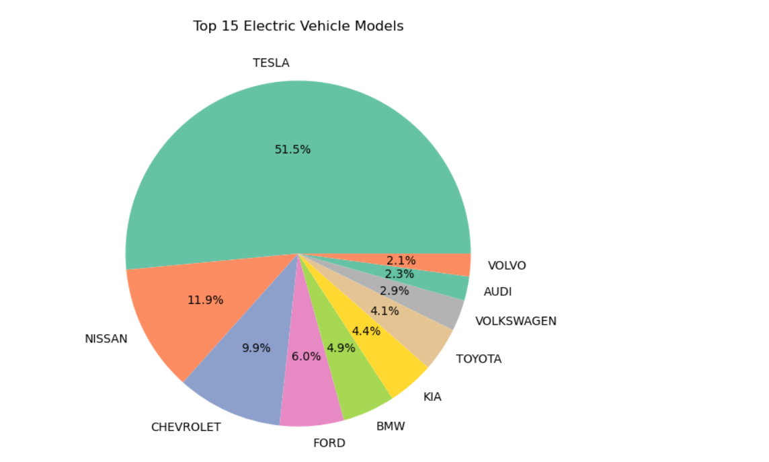

**Final Analysis:** This notebook does a great job of presenting basic but important insights from the EV dataset. The model year chart helps visualize how EV growth has accelerated in recent years, while the pie chart shows how one brand (Tesla) holds a strong majority of the market. The analysis is mostly descriptive and can **drill down** into each brand and see year wise growth for them.

**I.2.2 Electric Vehicle Population Analysis – IEEE Paper**

**Resource Description:**This IEEE paper focuses on using Microsoft Power BI to create interactive dashboards that visualize electric vehicle (EV) adoption across multiple U.S. states, with a strong focus on Washington. By integrating public registration data with map-based and brand-based charts, the study helps identify where EVs are being adopted and which types are most common. The resource stands out for its user-centered visual storytelling approach, turning raw data into informative visuals for both researchers and planners.

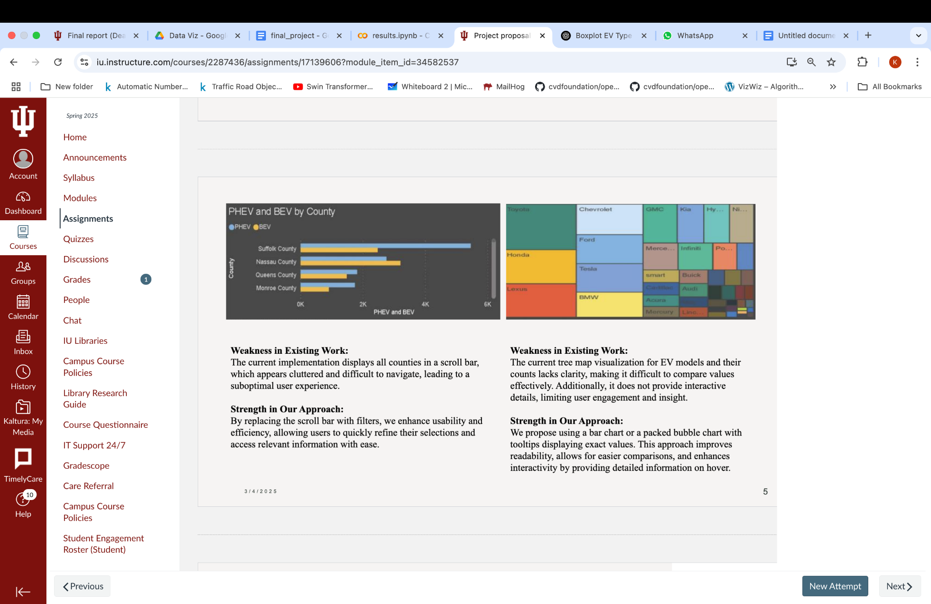

**Grouped bar chart:** The current implementation displays all counties in a scroll bar, which appears cluttered and difficult to navigate, leading to a suboptimal user experience.



**Treemap:** The current tree map visualization for EV models and their counts lacks clarity, making it difficult to compare values effectively. Additionally, it does not provide interactive details, limiting user engagement and insight.

**Final Analysis:** For the county-level analysis in Washington State, utilizing interactive geospatial tools such as Kepler.gl and choropleth maps significantly enhances insight generation by allowing users to visually explore regional EV adoption patterns with geographic precision. These tools enable dynamic filtering, zooming, and layering of data, making them far more effective than static charts or scrollable bars for spatial analysis. On the model-level side, using interactive treemaps, sunburst charts, sankey diagrams, and icicle plots allows for a comprehensive, hierarchical understanding of EV types, manufacturers, and market distribution. These visualizations support rich storytelling by revealing parent-child relationships, categorical flows, and proportional values.

**I.2.2 *The Insight of Electric Vehicle Population in Washington* (Ruan, 2023)**

**Resource Description:**Ruan’s 2023 conference paper takes a close look at electric vehicle registrations across Washington State. Using official data from the Washington State Department of Licensing, the study compares the growth of battery electric vehicles (BEVs) and plug-in hybrid vehicles (PHEVs), and identifies which brands and models are most common. What makes this study valuable is that it doesn’t just summarize EV totals — it highlights how adoption patterns differ across urban and rural areas and tracks changes over time, giving a fuller picture of Washington’s evolving EV landscape.

**Effectiveness and Techniques:**

* **Choropleth Map – EV Distribution by County:** This map shows how EVs are spread across different counties in Washington. Darker colors indicate counties with more EVs. King County leads with about 72,919 registered EVs, followed by Snohomish, Pierce, and Clark counties. The trend follows population size more people, more EVs.

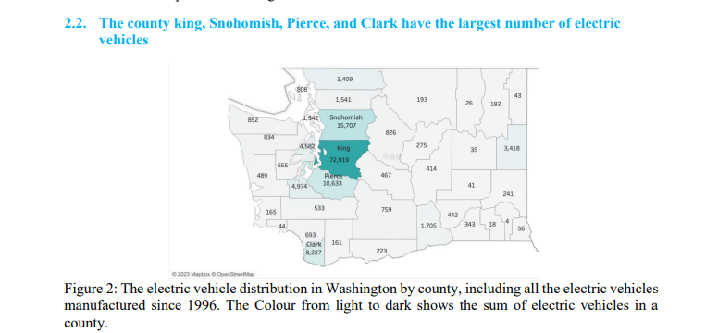

* **Bar Chart – Top EV Brands (2022 vs 2023):** This bar chart compares the top 5 electric vehicle brands (Tesla, KIA, Ford, Chevrolet, Jeep) between 2022 and 2023. **Tesla** remains the dominant brand, with a much higher number of vehicles compared to others. The chart also shows that most top-brand vehicles are BEVs rather than PHEVs, reflecting a growing preference for fully electric vehicles.

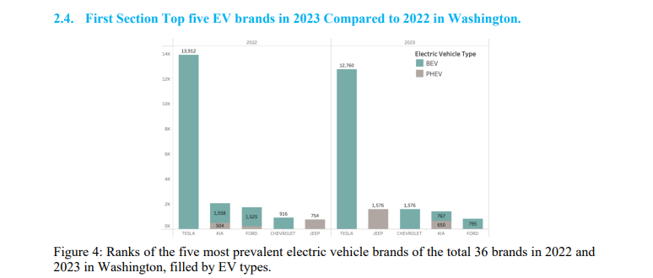

**Final Analysis:**The paper by Ruan gives a detailed snapshot of Washington’s EV adoption. The county map shows that EV ownership is heavily concentrated in large urban areas, emphasizing the need for expanded rural infrastructure. Meanwhile, the top brands chart highlights how BEVs, especially Tesla models, dominate the market. This reflects a strong consumer shift toward fully electric vehicles rather than hybrids. The study focuses only on 2022 and 2023 trends which do not fully show the growth of EV vehicles. Also an intensity map would better suit showing the continuous count of EV’s manufactured in the top counties.

**I.3 Contribution**

Our study advances the field of electric vehicle (EV) data analysis by addressing key gaps in existing research and visual analytics. While prior studies have focused on basic features analysis, our work delivers actionable insights through:

### **1. Integrated Analysis:**

We combine vehicle specifications (e.g., EV type, Make, Model), financial attributes (Base MSRP, CAFV eligibility), temporal data (model year), spatial dimensions( counties) and performance indicators (electric range) to provide a holistic understanding of electric vehicles. This multi-dimensional approach reveals how cost, range, and design intersect across different types of EVs (BEVs, PHEVs).

### **2. Innovative Visualization Techniques:**

* Bar graphs, sunburst, icicle and sankey charts go beyond static charts to offer a dynamic exploration of trends in pricing, electric range, and vehicle type.
* Using platforms like Kepler.gl, we created interactive visualizations that can be exported as HTML, enabling stakeholders to intuitively explore the data, filter variables, and uncover actionable insights.

### **3. Novel Insights:**

* Hierarchical Vehicle Segmentation: Through sunburst and icicle charts, we uncovered layered relationships between vehicle make, model, and electric vehicle type (BEV vs. PHEV). These visualizations expose brand-level contributions to EV variety and allow users to trace how specific manufacturers dominate certain EV categories.
* Interactive Exploration: Using Kepler.gl, we developed spatially-aware visualizations where geographic availability of EV types can be explored interactively. Stakeholders can filter by state, price bracket, or range tier to identify localized patterns in EV adoption and offering.

* Regional Policy Impact Analysis: The CAFV eligibility choropleth map by county uncovers spatial disparities in clean vehicle adoption, highlighting how local policies, incentives, and infrastructure significantly influence regional variations in CAFV penetration, providing actionable insights for targeted environmental policymaking.
* Vehicle Characteristics Analysis: The Visualizations consider the characteristics of a vehicle like its manufacturer, price and electric range which shows their impact on popularity among people.

### **4. Practical Applications:**

* Informed Buying Decisions: Consumers can leverage our visual tools to identify high-range vehicles within their budget, or to evaluate trade-offs between price and efficiency.
* Market Segmentation: Manufacturers and policymakers can identify pricing spots for BEVs or PHEVs, aiding in targeted production and subsidy planning.
* Performance Optimization: Insights into how price scales with electric range can help optimize EV design for cost-effective innovation.

### **5. Bridging Gaps in Existing Work:**

* Previous research often presented static and siloed metrics without contextual overlays. Our work bridges these gaps by integrating vehicle specifications with price, electric range into layered visual analytics.
* Kepler.gl provides interactive spatial layers and filterable views to identify the usage of electric vehicles.
* Advanced Visual Techniques: We utilize area charts, heatmaps, box and violin plots that visually encode multiple dimensions of the EV dataset, providing stakeholders with both macro and micro-level insights.

By combining technical rigor with intuitive design, our approach offers robust, data-driven insights that advance the discourse on EV affordability, performance, and market segmentation ultimately supporting better consumer choices, efficient policy design, and innovation in sustainable transportation.

**II. Data & Methods:**

**II.1 Dataset Description:**

The dataset originates from Washington state ([Washington State Open Data Portal](https://catalog.data.gov/dataset/electric-vehicle-population-data)), capturing detailed information on vehicle types, pricing, electric range, clean alternative fuel vehicle eligibility and geographic locations. It is an extensive and reliable resource for studying trends in EV adoption, pricing, and performance across various counties in washington. The dataset’s inclusion of both spatial and temporal data enables a multi-dimensional analysis of EV characteristics, fostering a deeper understanding of the factors influencing the adoption of clean vehicles.

The analysis utilizes a detailed dataset on electric vehicles across multiple regions in the United States. Key attributes that gave meaningful insights include:

* Vehicle Type: Categories such as BEV (Battery Electric Vehicle) and PHEV (Plug-in Hybrid Electric Vehicle)
* Vehicle specifications: Vehicle Make and Model
* Electric Range: The maximum number of miles that can be travelled before recharge.
* Base MSRP: The manufacturer's suggested retail price
* Geographic Data: County, city, state, and postal code of the vehicle’s location (Lat/Long embedded in “Vehicle Location”)
* Temporal Data: Model year
* Eligibility for Clean Alternative Fuel Vehicle (CAFV) incentives program

Other attributes are:

* VIN (Vehicle Identification Number)
* Legislative District
* DOL Vehicle ID
* Electric Utility
* 2020 Census Tract

**Coverage:**

The dataset spans registrations from 1999 to early 2025, offering both historical

and current perspectives on EV adoption.

**Size:**

The dataset has 232,321 rows and 17 columns, providing a robust foundation for analyzing trends in EV pricing, electric range, and adoption. The breadth of the dataset allows for detailed spatial and temporal breakdowns, offering a holistic view of the electric vehicle market.

**Skewness:** The features are not skewed. 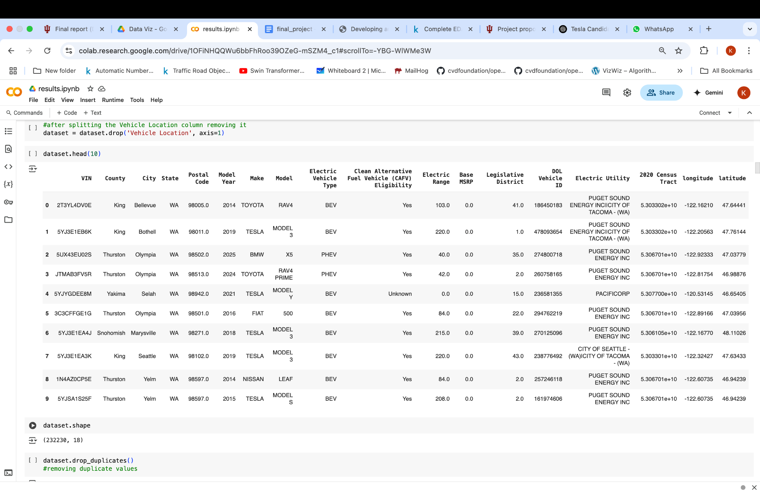

**II.2 Data Cleaning & Preprocessing**

The raw electric vehicle population dataset, although comprehensive, required significant cleaning and preprocessing to prepare it for analysis and visualization. High quality data is essential for producing reliable insights and therefore, each step in the cleaning process was carefully considered to ensure consistency, completeness and relevance.

### **Initial Inspection**

Here assessed the types of variables, the presence of missing values and any inconsistencies in the data. Summary statistics and metadata such as column names, data types and unique values for key fields (e.g counties) are reviewed to confirm that the dataset is appropriate for the project’s geographic focus on Washington State.

### **Standardizing Column Names**

To improve the clarity and ease of use, the column VIN (1-10) is renamed to simply VIN. This standardization streamlines the data handling process and makes future references to this field cleaner and more intuitive. Consistent naming conventions across the dataset avoids confusion during later stages of analysis.

### 

### **Recoding Categorical Variables**

Several categorical fields contain unnecessary long or inconsistent labels, which are simplified to make the data more manageable for analysis and visualization:

* The Electric Vehicle Type field, originally containing long descriptions such as "Battery Electric Vehicle (BEV)" and "Plug-in Hybrid Electric Vehicle (PHEV)," is recoded into shorter standardized categories: **BEV** and **PHEV**.
* Similarly, the Clean Alternative Fuel Vehicle (CAFV) Eligibility field, which includes detailed phrases describing eligibility status, is re-coded into simple labels: **Yes**, **No**, and **Unknown**.

These transformations improve the readability of charts, dashboards and tables, and ensure consistency when aggregating or comparing values across groups.

### **Parsing and Extracting Geospatial Data**

The dataset provides location information in a combined Vehicle Location field using a POINT (longitude latitude) string format. To enable effective geospatial mapping and geographic analyses, the longitude and latitude values are separately extracted into two new numeric fields: longitude and latitude.

After extraction, the original Vehicle Location field is removed to avoid redundancy. Having clean, numeric latitude and longitude values allows for accurate spatial plotting in choropleth maps and other geospatial visualizations.

### 

### 

### 

### 

### 

### **Handling Missing Values**

Addressing missing data is a critical step to ensure the reliability of the analyses. An evaluation of missing values across all fields reveals that some records lack important information such as electric vehicle type, make, model, electric range or base MSRP.

Rather than imputing values, which could introduce bias, records with missing values are dropped entirely. This ensures that subsequent analyses particularly those focused on economic and technological factors are based only on complete trustworthy entries. Totally only 0.26% of the data is dropped.

### **Removing Duplicate Records**

To avoid double counting vehicles, the dataset is checked for duplicate entries. Duplicate records are identified based on the VIN field, which should be unique to each vehicle. Any duplicates found are removed to preserve the accuracy of registration counts and market share calculations.

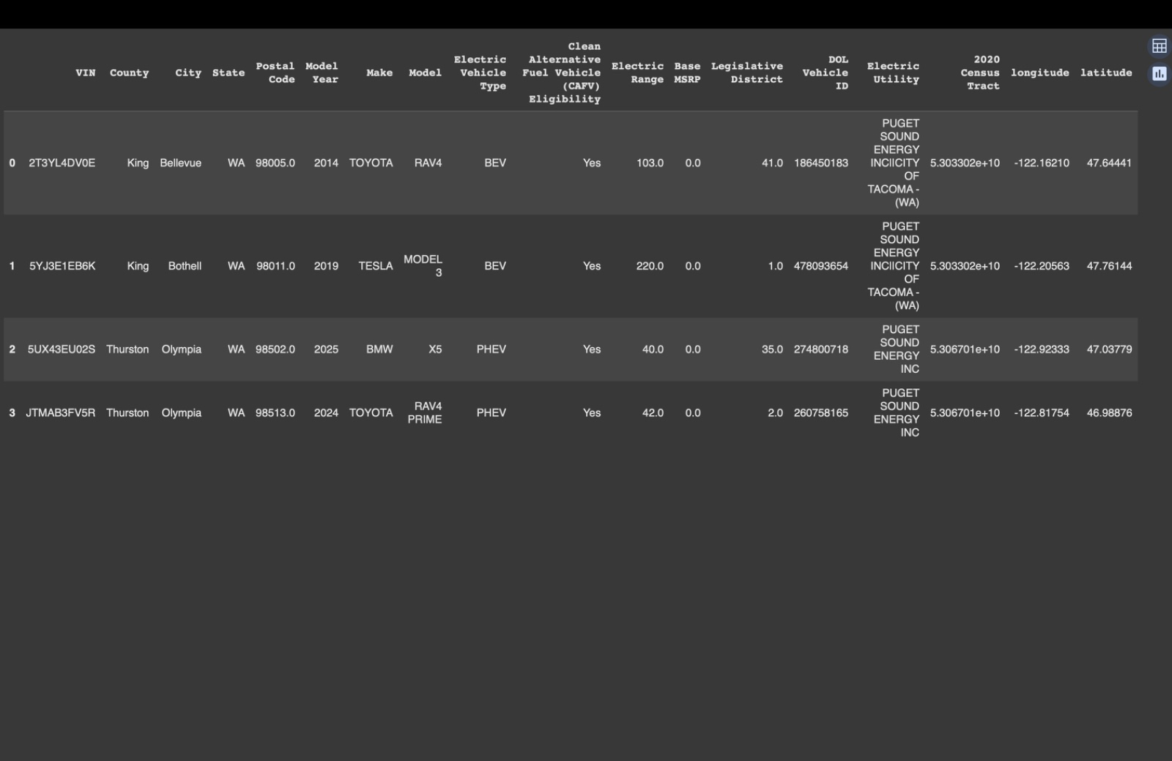

**III.3 Ideas, Sketched & Prototypes:**

To effectively visualize the electric vehicle adoption data for Washington state, our team began by thoroughly exploring multiple visualization techniques through sketches and detailed prototypes. The goal at this stage was to identify the best visual representations to clearly communicate the underlying trends, distributions, and relationships within our dataset. Below are the comprehensive ideas, sketches, and subsequent refined prototypes we developed:

**1. Time-Series Chart:**

**Idea:** To capture temporal adoption trends of electric vehicles, this line chart visualizes the number of EVs by model year from 2000 to 2025. It helps identify growth patterns, adoption spikes, and plateaus over time. Such insights are valuable for policymakers and manufacturers to align incentives, production, and infrastructure planning with evolving market dynamics.

**Sketch and Prototype:**

A linear timeline with annotations highlighting key technological breakthroughs.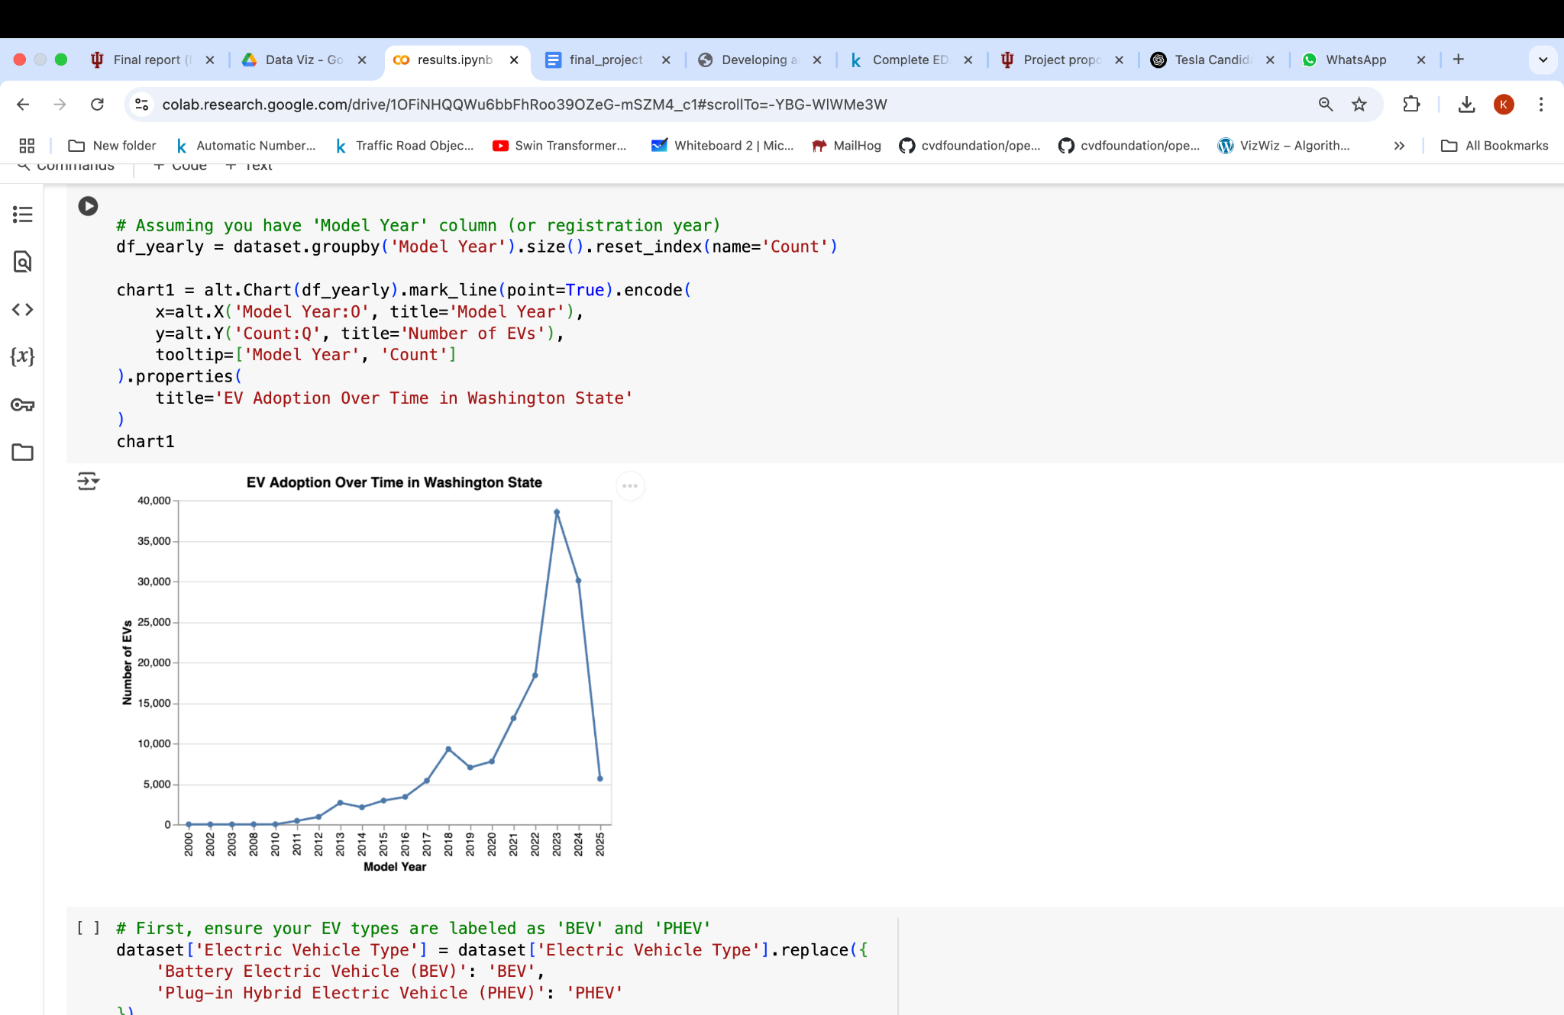

This line graph shows growth in the number of EVs by model year from 2000 to 2025. The x-axis is the model year of the vehicles, while the y-axis is the number of EVs registered, ranging up to 40,000 units. This enables clear tracking of changes and highlighting overall trends in EV adoption over time. The axes and title are perfect, with consistent spacing between points to enhance readability. Its clean design avoids visual clutter, making it effective for presenting high-level temporal patterns. Future enhancements, such as interactive tooltips or annotations for policy changes, could enrich the experience. Like the area chart, the animated bar chart in-detail explains how each make (brand) has contributed to the growth over years.

**2. Categorical Analysis:**

**Idea:** To understand the distribution of Clean Alternative Fuel Vehicle (CAFV) eligibility among registered EVs, this pie chart visualizes the proportion of vehicles classified as Yes, No and other Unknown. This offers valuable insights for assessing policy reach, identifying gaps in incentive coverage, and evaluating the market’s alignment with clean vehicle initiatives.

**Sketch and Prototype:**

A circular pie chart with distinct segments for each CAFV eligibility category.

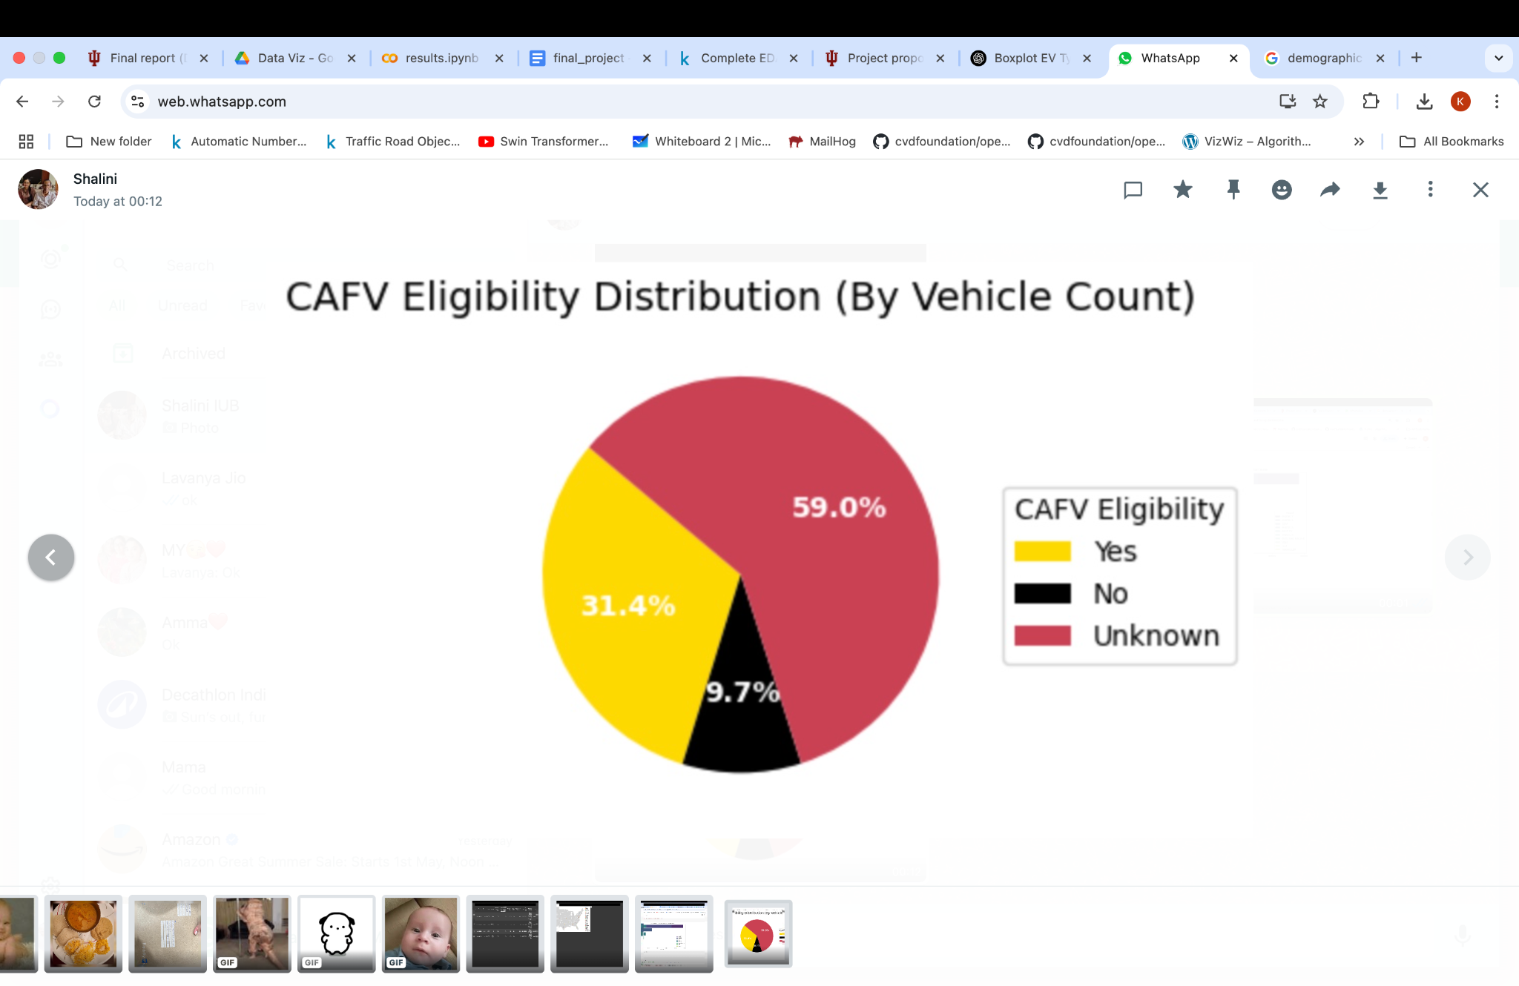

This pie chart depicts the proportion of electric vehicles categorized by their CAFV eligibility status. Each segment represents a category such as Yes, No and other Unknown with labels and percentages shown either inside or beside each slice. The chart is color-coded for clarity, with a legend and concise title to enhance interpretability. This simple yet effective visualization allows stakeholders to quickly gauge how well the EV market aligns with clean fuel program criteria. Future improvements might include drill-down interactivity to explore eligibility by vehicle make, model, or county for deeper policy analysis like using choropleth map for detailed analysis in each county in the washington state and stacked bar graph to analyze the eligibility by vehicle specification (make).

**3. Geographical Analysis:**

**Idea:** To visualize the geographic distribution of electric vehicles across U.S. counties, this layered map overlays EV location points on top of a U.S. state boundary map. This spatial perspective helps identify regional adoption patterns and highlights states (washington, california, new york) with notable EV presence registered through Washington state, which is valuable for planning charging infrastructure, local policy formulation, and regional market analysis.

**Sketch and Prototype:** A map of the U.S. with state-level EV data represented as colored circular points. The base map provides geographic context using state boundaries, while colored dots indicate different counties, positioned by their longitude and latitude.

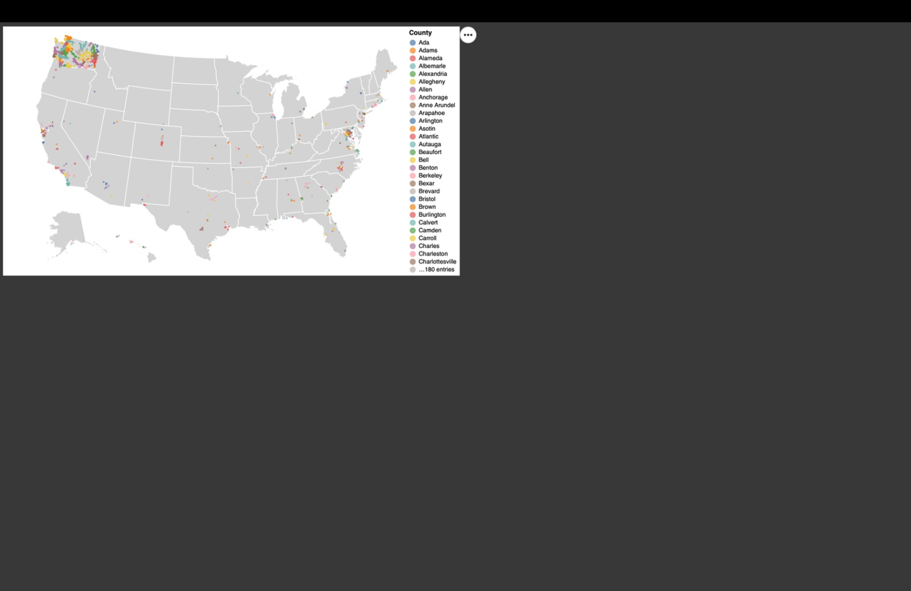

This geospatial map illustrates where electric vehicles are registered across the United States. The background uses U.S. state boundaries to give geographical context, while each point on the map represents an EV's location, plotted using its longitude and latitude. The color of each point corresponds to the county, allowing for quick visual differentiation and identification of dense or sparse regions.

Instead, making a county level analysis of each state separately will help us understand the adoption of EV clearly. In our case, Washington state is considered because it is one of the leading states with leading electric vehicle adoption. Kepler.gl is more interactive and can be filtered county wise or based on the type of electric vehicle. Or the choropleth map helps us to understand the CAFV eligibility county wise.

**4. Categorical Distribution Analysis**

**Idea:** To highlight the most popular electric vehicle (EV) models within top manufacturers, this stacked bar chart visualizes the top 10 EV makes and their respective model distributions in Washington State. It reveals which models dominate each brand’s presence, offering actionable insights for manufacturers, dealers, and policymakers regarding consumer preferences and market share distribution.

**Sketch and Prototype:** A horizontal stacked bar chart where each bar represents a vehicle make, segmented by its contributing models.

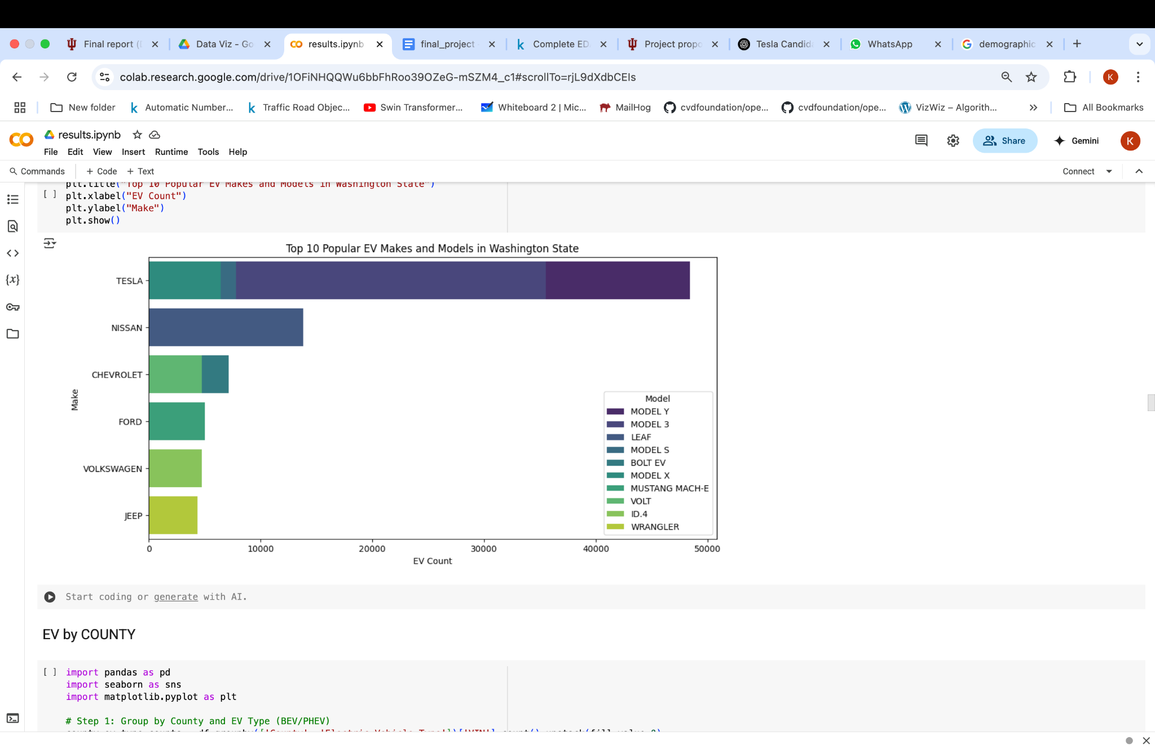  
This chart displays the top 10 EV makes by EV count, with each bar stacked to show the distribution of their most common models. The x-axis measures the EV count, while the y-axis lists the vehicle makes. Color-coded segments differentiate models within each make, allowing for quick comparison of model-level popularity within brands. The chart includes a concise title and labeled axes, with an emphasis on clarity and accessibility. Future enhancements could include interactive elements like model hover-details or filters to explore additional makes and models beyond the top 10.

**5. Characteristics Analysis**

**Idea:** To explore the relationship between electric vehicle affordability and performance (electric range), this heatmap visualizes the distribution of electric vehicles over price and range and informs purchasing decisions or policy incentives targeting value-for-money segments.

**Sketch and Prototype:**

A two-dimensional heatmap with Base MSRP on the x-axis and Electric Range on the y-axis. Each grid cell is color-coded based on the number of vehicles falling into that bin, with a color scale indicating density.

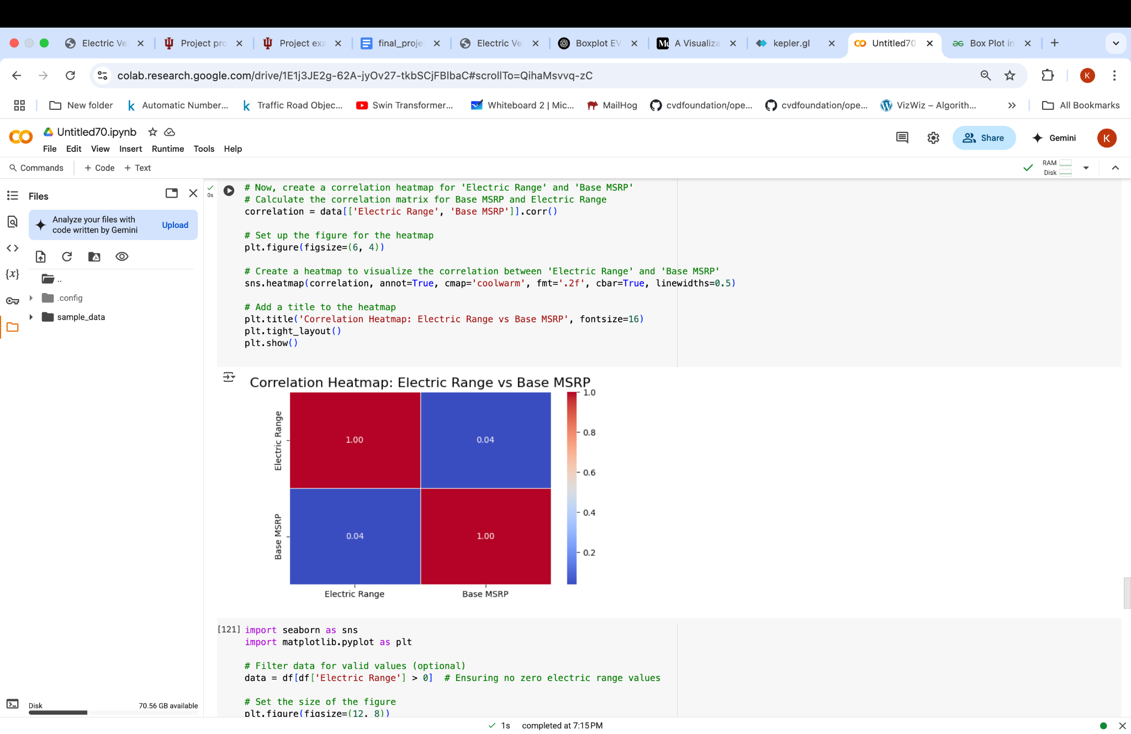

This heat map illustrates how electric vehicles (EVs) are distributed across combinations of base MSRP (price) and electric range (miles). Here, in the heatmap it is not guaranteed that if the price of the vehicles is increased the range increases or vice-versa. So the box plot is used to check electric driving range (in miles) varies across different vehicle price categories.

**Summary:**

Each visualization prototype underwent iterative sketching, feedback incorporation, and enhancements, ensuring robust analysis alignment, clarity of communication, and user-friendly navigation. Through this rigorous process, we validated and refined each visualization method to effectively meet our analytical objectives and enhance user interaction with the dataset.

**IV Visualization Methods selection:**

## **1. Line Chart:** Ideal for displaying trends over time, such as number of EV registrations by model year.

### **Pros:**

* Clearly shows continuous changes and yearly trends over time.
* Highlights periods of sharp growth or decline effectively.
* Provides a clean, simple, and uncluttered view even with a long time range.

**Cons:**

* Doesn’t emphasize cumulative volume or total registrations as strongly as area charts.
* May understate the total growth impact when compared to shaded visualizations.

**Suitability:** Line charts are well-suited for visualizing yearly trends in electric vehicle (EV) adoption by model year. They effectively highlight growth patterns and adoption spikes, making them valuable for tracking market evolution and informing policy and infrastructure decisions.

**2 Stacked Bar Chart:** Ideal for comparing EV counts across different makes and their associated models.

**Pros:**

* Effectively displays part-to-whole relationships within each make (e.g., model distribution).
* Highlights dominant makes in a single visualization.
* Easy to compare category contributions side-by-side.

**Cons:**

* Can become cluttered with too many segments or categories.
* Harder to compare specific segments (models) across bars.

**Suitability:**Stacked Bar charts are ideal for showcasing the popularity of different EV makes and their top models. They offer a clear breakdown of EV distribution, helping stakeholders understand consumer preferences and market dominance within specific brands.

**3 Sunburst Chart**

A sunburst chart is selected to visualize the hierarchical distribution of electric vehicle registrations by make and model in Washington State.  
This visualization structure effectively captures the parent-child relationships between makes and models, while also emphasizing their relative proportions in the market.

### **Pros:**

* Clearly represents hierarchical relationships across two or more levels.
* Efficiently displays part-to-whole proportions within a compact circular layout.
* Allows quick identification of dominant manufacturers and models.
* Interactive tooltips enhance user understanding by providing detailed counts and percentage shares.

### **Cons:**

* Labels for smaller segments can become difficult to read without careful design.
* When many minor categories exist, the outer rings may appear crowded.

**Suitability:** The sunburst chart is the most suitable choice because it visually highlights major players such as Tesla, Chevrolet, and Nissan, while maintaining an intuitive and attractive format. It aligns well with the project’s goal of making the EV market structure accessible and easy to explore.

## **4 Sankey Diagram**

A Sankey diagram is selected to visualize the flow from electric vehicle types (BEV, PHEV) to manufacturers and then to specific models. This visualization effectively shows how the EV population branches across multiple categorical levels, emphasizing both structure and magnitude.

### **Pros:**

* Clearly visualizes multi-level relationships between categories.
* The width of the flows intuitively represents the quantity at each stage.
* Highlights dominant manufacturers and models through proportional link thickness.
* Allows users to trace the hierarchy and flow of data across different levels easily.

### **Cons:**

* Can become visually dense if too many small categories are included.
* Requires careful layout and design to maintain readability with large datasets.

**Suitability:** the Sankey diagram is the best choice because it effectively captures both the structure and magnitude of EV market distribution. It aligns with the project’s goal of providing a comprehensive and engaging overview of how EV types connect to manufacturers and their leading models.

**6. Icicle Chart**

An icicle chart is selected to visualize the hierarchical distribution of electric vehicle registrations across types, manufacturers, and models in Washington State.  
The icicle layout presents the structure of the EV population in a clean, top-down format that is intuitive for exploring multiple levels of hierarchy.

### **Pros:**

* Clearly displays parent-child relationships across multiple categorical levels.
* Maintains a logical, compact structure even for large datasets.
* Allows users to drill down through categories (EV Type → Make → Model) easily.
* Provides a proportional visual sense of each category's contribution through rectangle size.

### **Cons:**

* Does not emphasize the volume flow between stages as strongly as a Sankey diagram.
* Can become less visually dynamic compared to circular or radial layouts when many categories have very small values.

**Suitability:**the icicle chart is highly effective for this project because it balances readability, hierarchical structure, and detailed exploration. It enables users to understand the composition of the EV market from broader categories down to specific models, supporting the project’s goal of clear hierarchical market analysis.

**V. RESULTS**

1. **How has the adoption of electric vehicles (EVs) changed over time in Washington State between battery electric vehicles (BEVs) and plug-in hybrid electric vehicles (PHEVs) and are there any years with notable spike or improvement in EV adoption.**
2. **EV adoption over time by electric vehicle type**

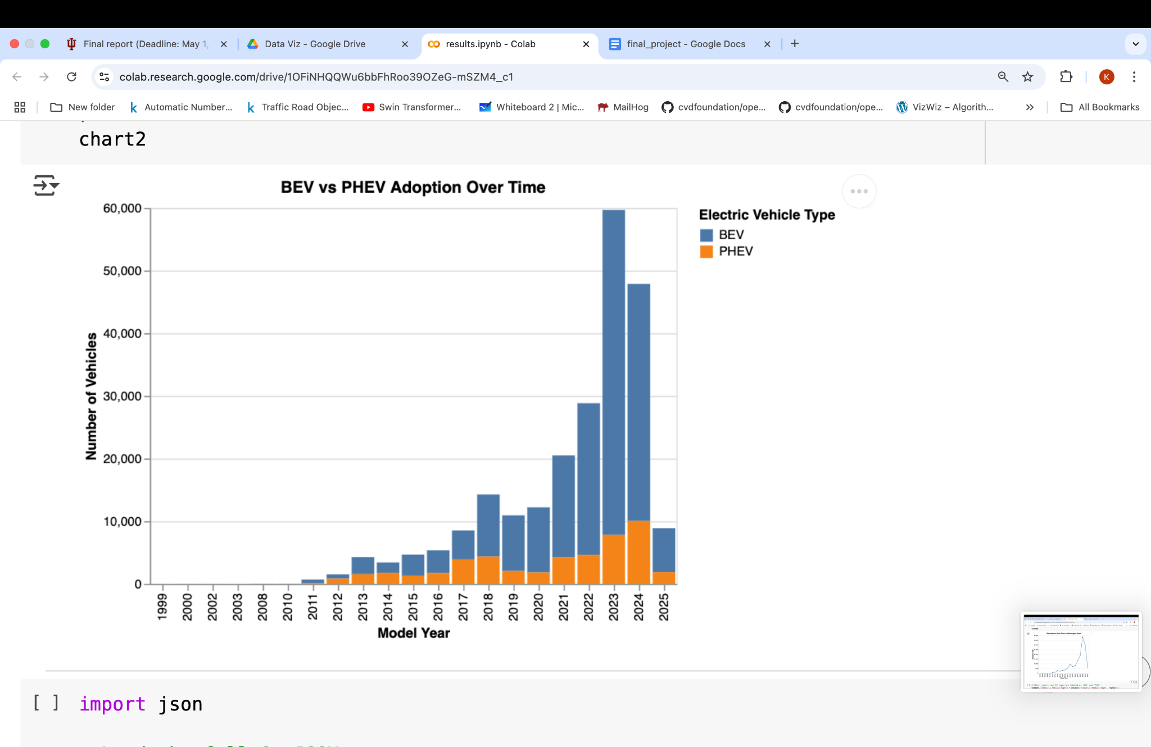

This stacked bar chart displays the adoption trends of two types of electric vehicles in Washington State: Battery Electric Vehicles (BEVs) and Plug-in Hybrid Electric Vehicles (PHEVs).

The x-axis shows the model year from 1999 to 2025, while the y-axis represents the number of vehicles, scaling up to 60,000. Each bar is divided into two segments: the larger blue section for BEVs and the smaller orange section for PHEVs. The visualization highlights that BEV adoption has grown much more significantly compared to PHEVs, especially from around 2018 onwards. BEVs dominate the later model years, with a sharp surge peaking at the 2022–2023 model years. PHEV adoption, while present, remains relatively smaller throughout the timeline.

This visualization clearly shows not only the growth of EVs over time but also how consumer preference has increasingly shifted toward fully electric (BEV) models rather than hybrids.

### **Advantages:**

* **Comparison Between Vehicle Types:** It clearly separates BEV and PHEV adoption, making it easy to compare the popularity of the two technologies over time.
* **Good Visual Representation of Volume and Growth:** The stacked bars allow for an immediate sense of the total number of EVs while still showing how much each type contributes to the overall count.

### **Disadvantages:**

* **Recent Data May Again Be Incomplete:** Like the previous graph, the sharp decline in 2024–2025 could mislead viewers if they do not realize the data for those model years might not be finalized yet.
* **Rescaling the Timeline**: We don’t see any significant values change from 1999 to 2010 so the x axis can be rescaled from 2010 to 2025.

1. **Time series analysis of top 10 makes**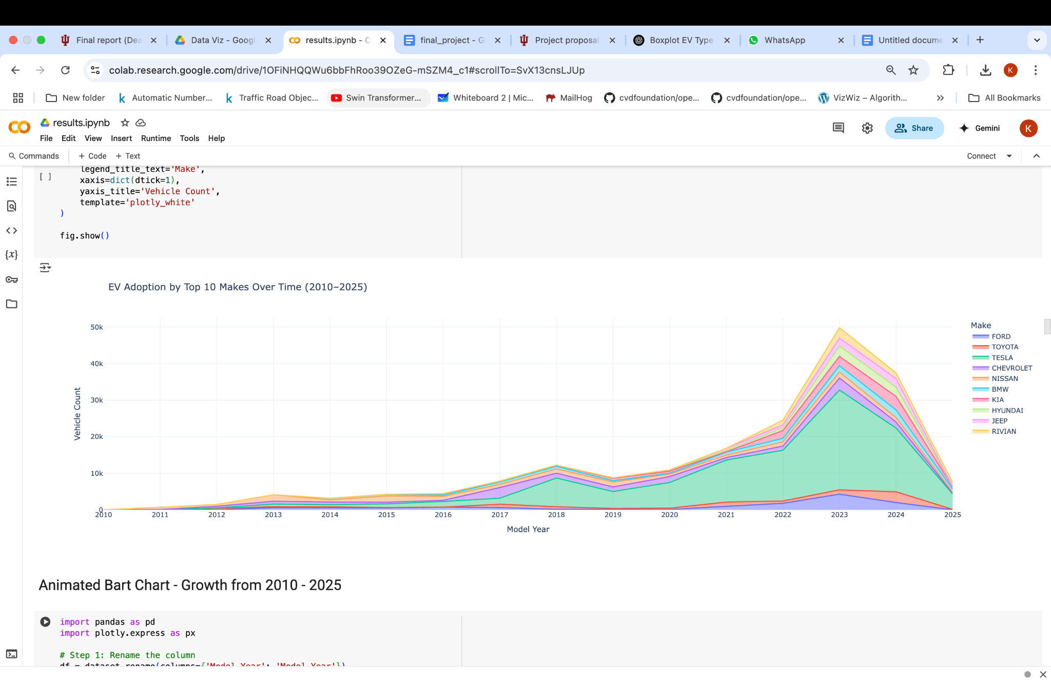

This area chart visualizes the adoption trends of electric vehicles (EVs) by the top 10 most popular makes in Washington State from 2010 to 2025. The x-axis shows the model year ranging from 2010 to 2025, while the y-axis represents the number of ev’s registered. Each colored area corresponds to a specific EV make, allowing for a cumulative view of their growth trajectories over time. The chart highlights a consistent rise in EV adoption across most brands, with certain makes like Tesla and Nissan showing a more dominant presence in recent years. The stacked layers convey not only the individual growth of each make but also the total expansion of the EV market.This visualization effectively captures brand-level momentum and provides valuable insights into how different automakers have contributed to the statewide transition toward electric mobility.

**Advantages:**

* **Cumulative Trend Clarity:** Shows both individuals make contributions and total EV adoption over time.
* **Rescaling the Timeline:** Years prior to 2010 showed minimal EV activity, so the chart begins from 2010 to better emphasize meaningful adoption patterns.
* **Comparative Insights:** Highlights market competition and changing consumer preferences among top EV makes.

**Disadvantages:**

* **No Breakdown by Vehicle Type:** This chart focuses solely on make and year, omitting BEV vs. PHEV differences.

**3. Cumulative EV Adoption by Top 10 Makes (2010–2025)**

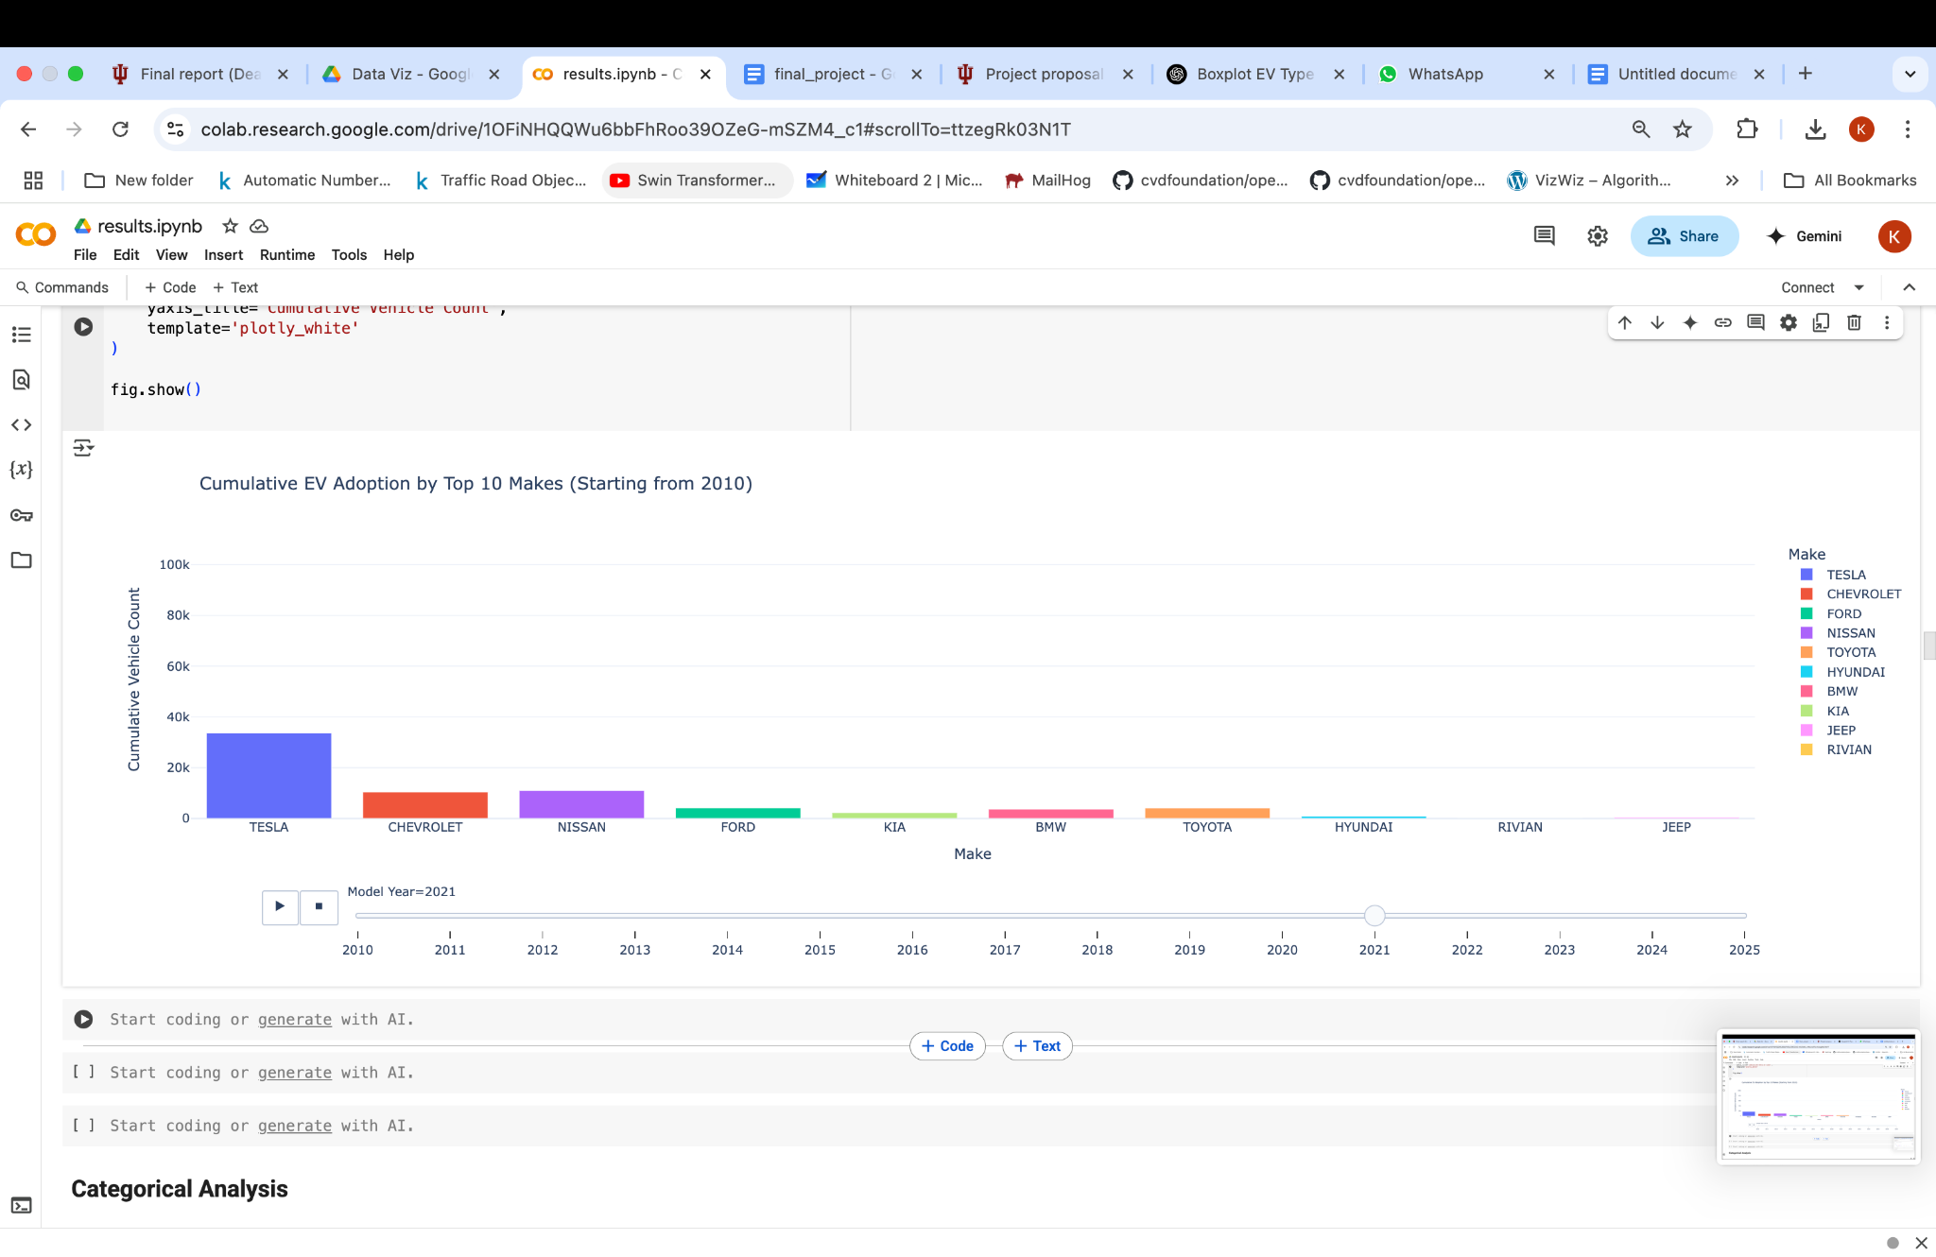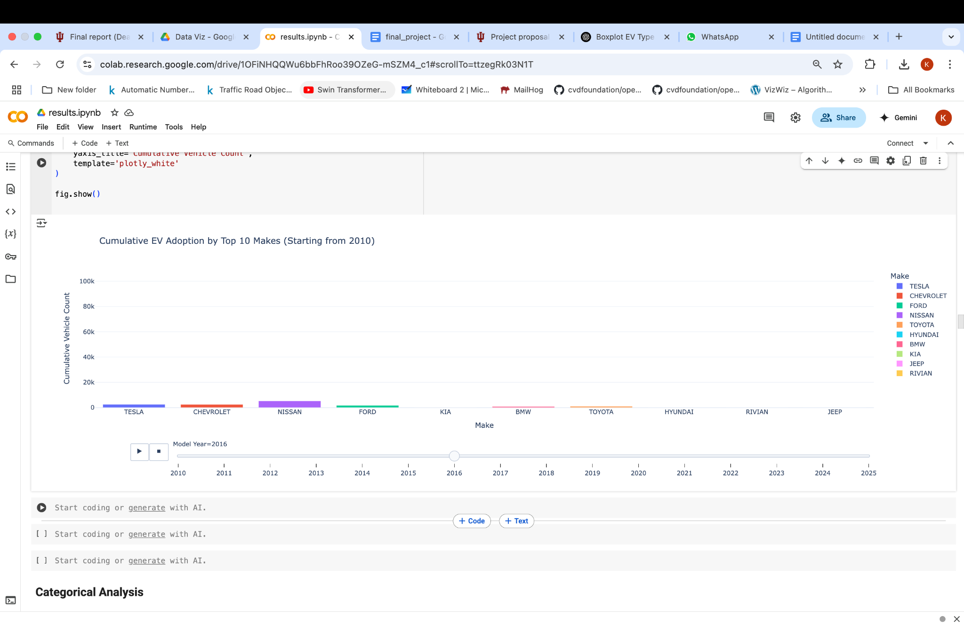

This animated bar chart presents the cumulative adoption of electric vehicles (EVs) by the top 10 makes in Washington State from 2010 to 2025. Each frame represents a specific model year, with the x-axis listing the top 10 EV makes and the y-axis displaying the cumulative number of registered vehicles up to that year. The animation showcases how different automakers have contributed to the rising EV landscape over time. As the years progress, brands like Tesla and Nissan climb steadily, reflecting their dominant positions in the market. The motion element helps convey the pace and acceleration of adoption more intuitively than a static chart.

**Advantages:**

* **Dynamic Visualization of Growth:** Clearly shows how each make’s presence has expanded cumulatively over time.
* **Engaging Storytelling:** Animation adds a temporal narrative, making long-term trends easier to grasp.
* **Easier to Analyze Exact Values:** Viewers may use tooltips on each bar to read precise values and increase in count during animation.

**Disadvantages:**

* **Hierarchical Comparison:** This chart focuses solely on make. As an improvement it can drill down on models and other specifications like electric range or cost to get further insights.

**B. How do Electric Vehicles distribute across counties in Washington State? Which counties are top adopters of BEVs and PHEVs and how growth has increased in those counties? Does growth vary in urban and rural zones?**

1. **Interactive EV distribution visualization using Kepler.gl**

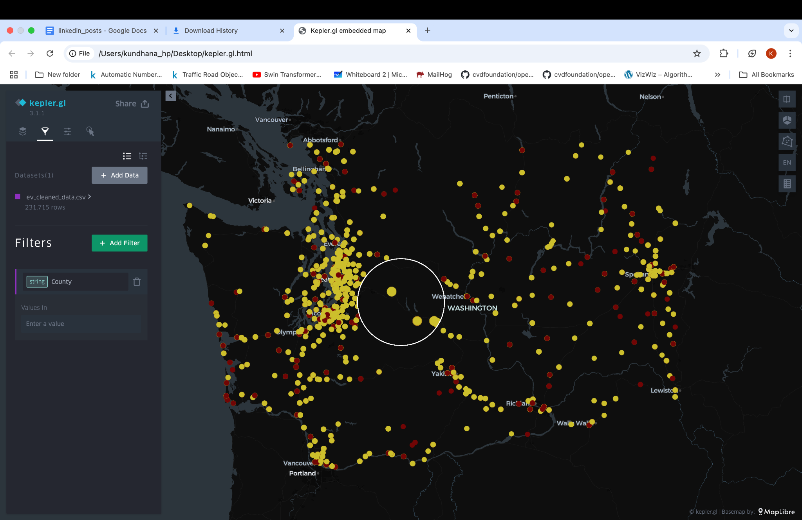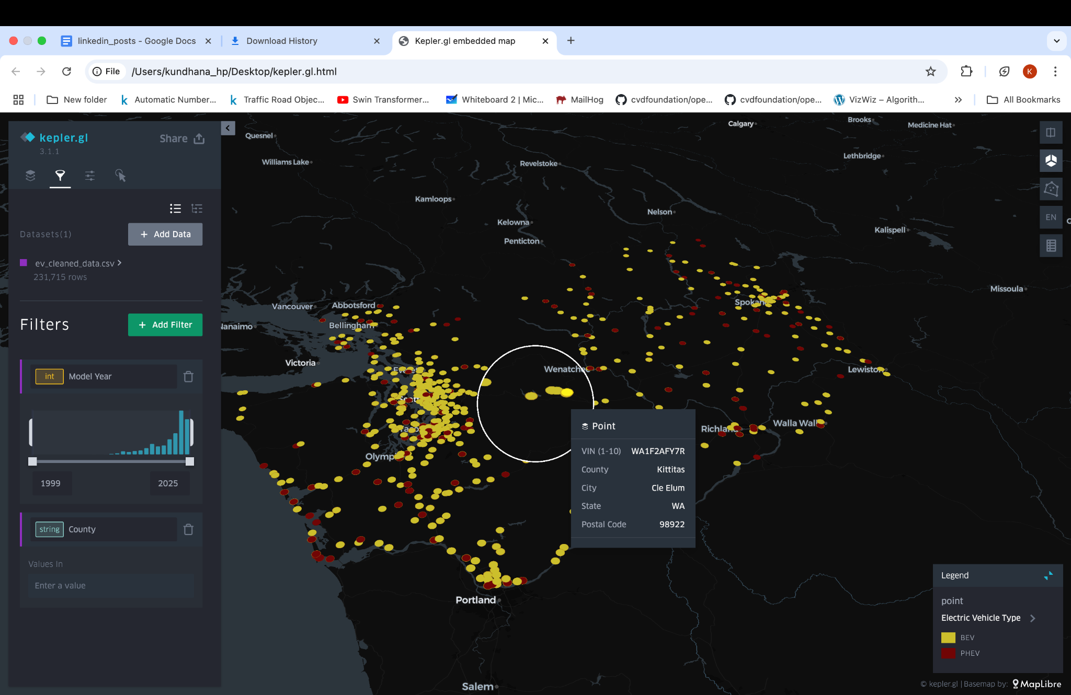

This interactive map, created using Kepler.gl, provides a visually striking representation of electric vehicles (EVs) across Washington State using color-coded circular markers.

Each point on the map represents an EV, and the points vary in color, likely based on additional attributes like vehicle type. The yellow circle represents the BEV whereas the red circle represents PHEV.

The first map (top) focuses on the central and western parts of Washington, highlighting areas like Grant County, while the second map (bottom) zooms in on the greater Seattle metropolitan area in western Washington. Additional interactive features like tooltips show specific data (VIN, city, county, state, postal code) when hovering over a point, and sidebar controls allow users to apply filters by model year and other characteristics.These maps provide a detailed view of where EV adoption is concentrated across the state, making spatial patterns easily visible. We can infer that western urban parts have more adoption than eastern rural parts.

There are some points that are overlapped. So, the white circle on the map is used as a magnifier to see the points clearly zoomed.

### **Advantages:**

* **Shows Spatial Patterns Clearly:** The maps effectively reveal that EV adoption is heavily concentrated around urban centers like Seattle, while rural areas have much lower densities.
* **Interactive and Detailed:** The use of tooltips and filters adds depth, allowing users to explore specific locations, timeframes, or types of EVs for a richer understanding.

### **Disadvantages:**

* **Color and Size Overlap Can Cause Clutter:** In densely populated areas, overlapping points can make it difficult to distinguish individual data points or accurately estimate counts without zooming in.
* **Less Effective for Quantitative Comparison:** While the map shows *where* EVs are, it’s harder to precisely compare total numbers between counties or cities compared to a bar or table format.

1. **EV distribution by County**

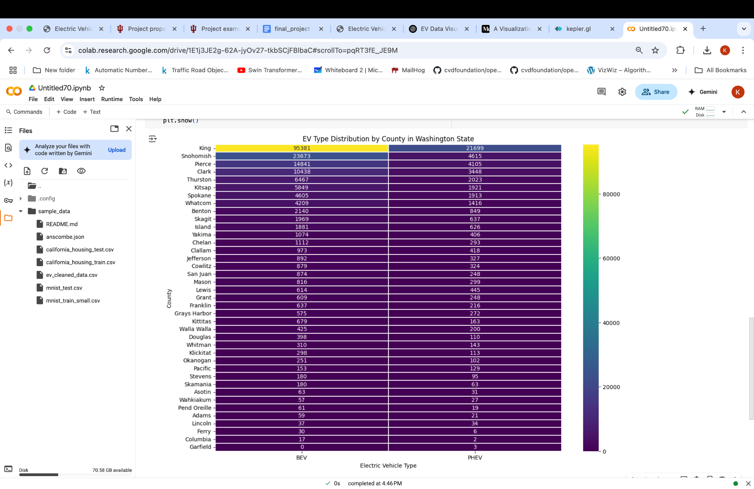

This EV Type Distribution by County in Washington State uses a heatmap-style table to display the number of BEVs and PHEVs across different counties. The counties are listed vertically on the y-axis, and the vehicle types are shown horizontally along the x-axis. Color intensity represents the number of vehicles, with brighter colors (yellow) indicating higher values and darker shades (purple) indicating lower values. Viridis color palette is used here to maintain uniform perception of colors. King County stands out with the highest EV counts, followed by Snohomish, Pierce, and Clark counties. In contrast, rural counties such as Garfield and Columbia show minimal EV adoption. This heatmap offers a quick visual understanding of where EVs are most and least concentrated throughout Washington State.

### **Advantages:**

* **Clear Comparison:** It makes it easy to quickly compare EV adoption levels between counties.
* **Effective Use of Color:** The color gradient immediately highlights areas with high and low EV counts without needing to read all the numbers.

### **Disadvantages:**

* **Hard to See Small Differences:** In counties with similar low EV numbers, the color shades are very close, making fine distinctions hard to detect.

1. **Top 10 counties and number of EV’s**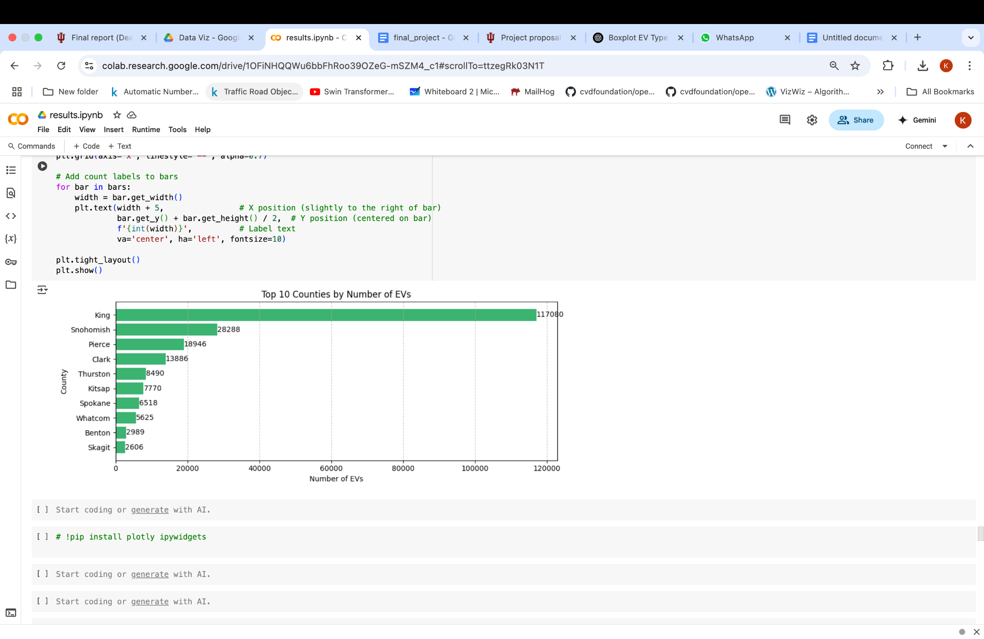

This horizontal bar chart shows the distribution of electric vehicles (EVs) across the top counties. Counties are listed along the y-axis, while the x-axis indicates the number of EVs.

The visualization highlights King County with a dramatically higher EV count compared to others, followed by Snohomish, Pierce, and Clark counties. There is a steep drop-off after the top few counties, making the differences in EV adoption between regions very clear. The simple, clean layout focuses on the top contributors to EV adoption and provides a strong visual impact regarding regional disparities.

### **Advantages:**

* **Easy to Read and Interpret:** The horizontal bar format makes it simple to compare values across counties without needing to interpret complex visual cues.

### **Disadvantages:**

* **Extreme Value Differences Skew Visualization:** The very large number for King County stretches the scale, making it harder to visually distinguish differences among smaller counties. And the population of counties also plays a part in skewing the graph. It is best to use normalized values or EV count per capita to compare counties.

**C. How do consumer preferences for electric vehicle makes and models vary across Washington state, and do these preferences differ between Battery Electric Vehicles (BEVs) and Plug-in Hybrid Electric Vehicles (PHEVs)?**

1. **EV Distribution by Make and Model using sunburst chart**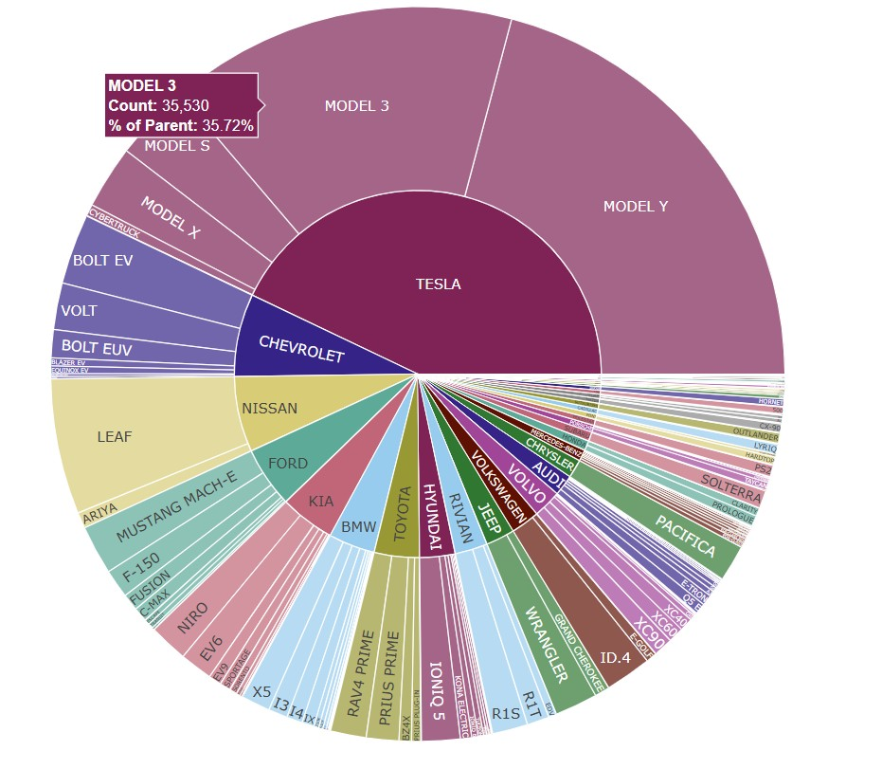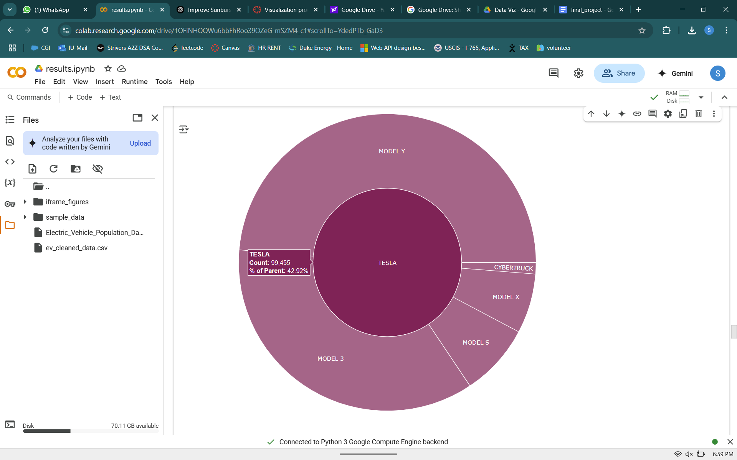

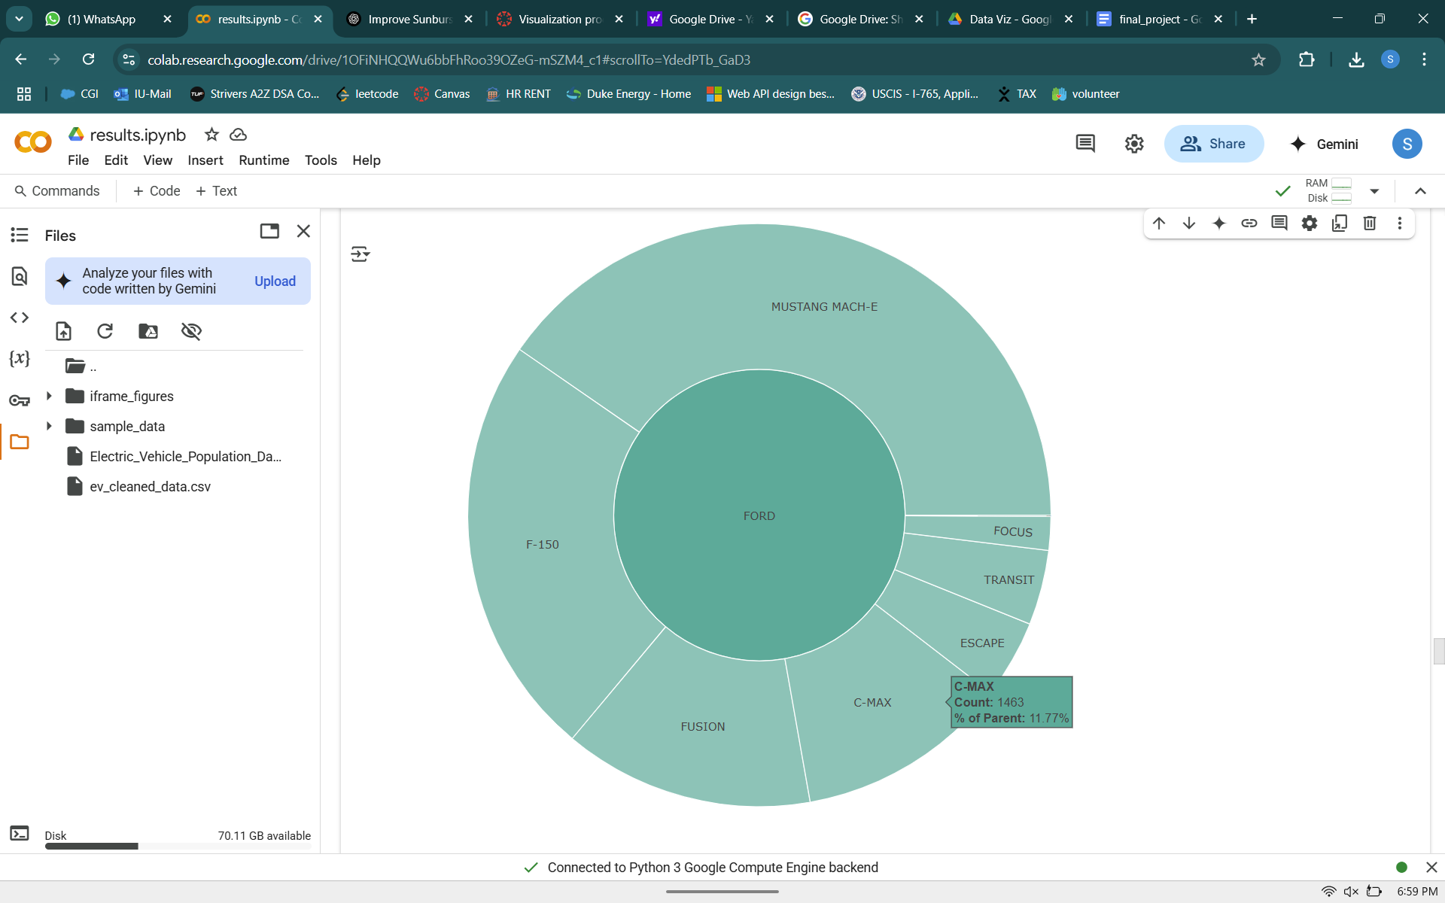

The purpose of this visualization is to analyze and present the distribution of electric vehicles based on their Make and Model hierarchies.  
 By doing so, we aim to:

* Understand which vehicle makes dominate the electric vehicle market,
* Explore the diversity of models offered by leading manufacturers,
* Provide a clean, intuitive view of vehicle brand and model popularity.

This insight helps stakeholders quickly recognize brand strengths and model variety within the electric vehicle ecosystem.

**Advantages:**

* **Efficiently Represents Hierarchies:** The Sunburst chart organizes the data into clear layers (Make ➔ Model), making it easy to understand relationships at a glance.
* **Maximizes Space with Multiple Branches:** Even with many models under each make, the circular layout ensures an efficient use of space without overwhelming the viewer.
* **Visualizes Proportions at Every Level:** The chart shows not just counts but also how much each model contributes relative to its make, and each make relative to the total.
* **Intuitive and Visually Appealing:** The design naturally guides the eye from the center outward, making it simple for users to drill down into detailed categories.
* **Maintains Clarity Across Multiple Levels:** Unlike bar charts or treemaps, the Sunburst allows for multilevel breakdowns while preserving clarity, even as users explore deeper layers.

**Disadvantages :**

### **Overcrowding Due to Many Makes and Models:** Initially, plotting all available makes and models resulted in a highly cluttered and overwhelming sunburst chart. Many makes with very few registrations contributed little value but added noise, making it difficult to focus on major market patterns.

### **Solution : Pre-filtering Top Makes**

To resolve this, a filtering step was introduced:  
We first selected only the Top N Makes (e.g., Top 5 by vehicle count) before grouping by model. This significantly reduced clutter and allowed the chart to focus on market leaders while still showing the diversity among their models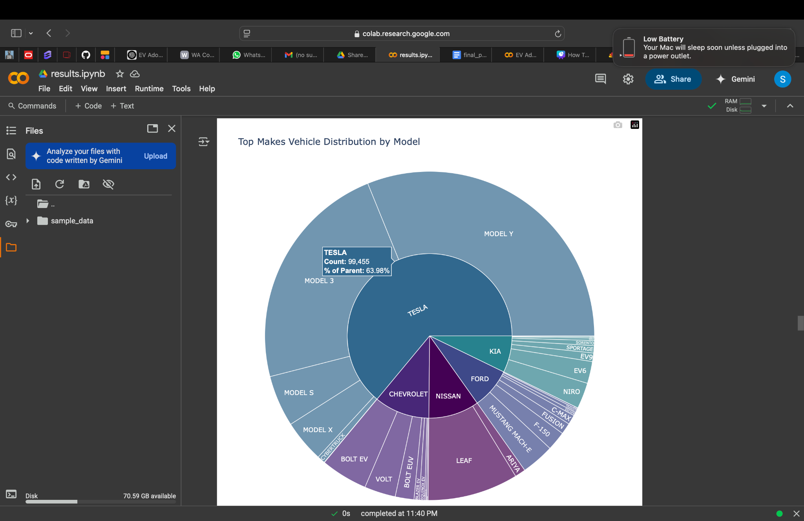

**2. EV Distribution by Make and Model (Icicle Chart)**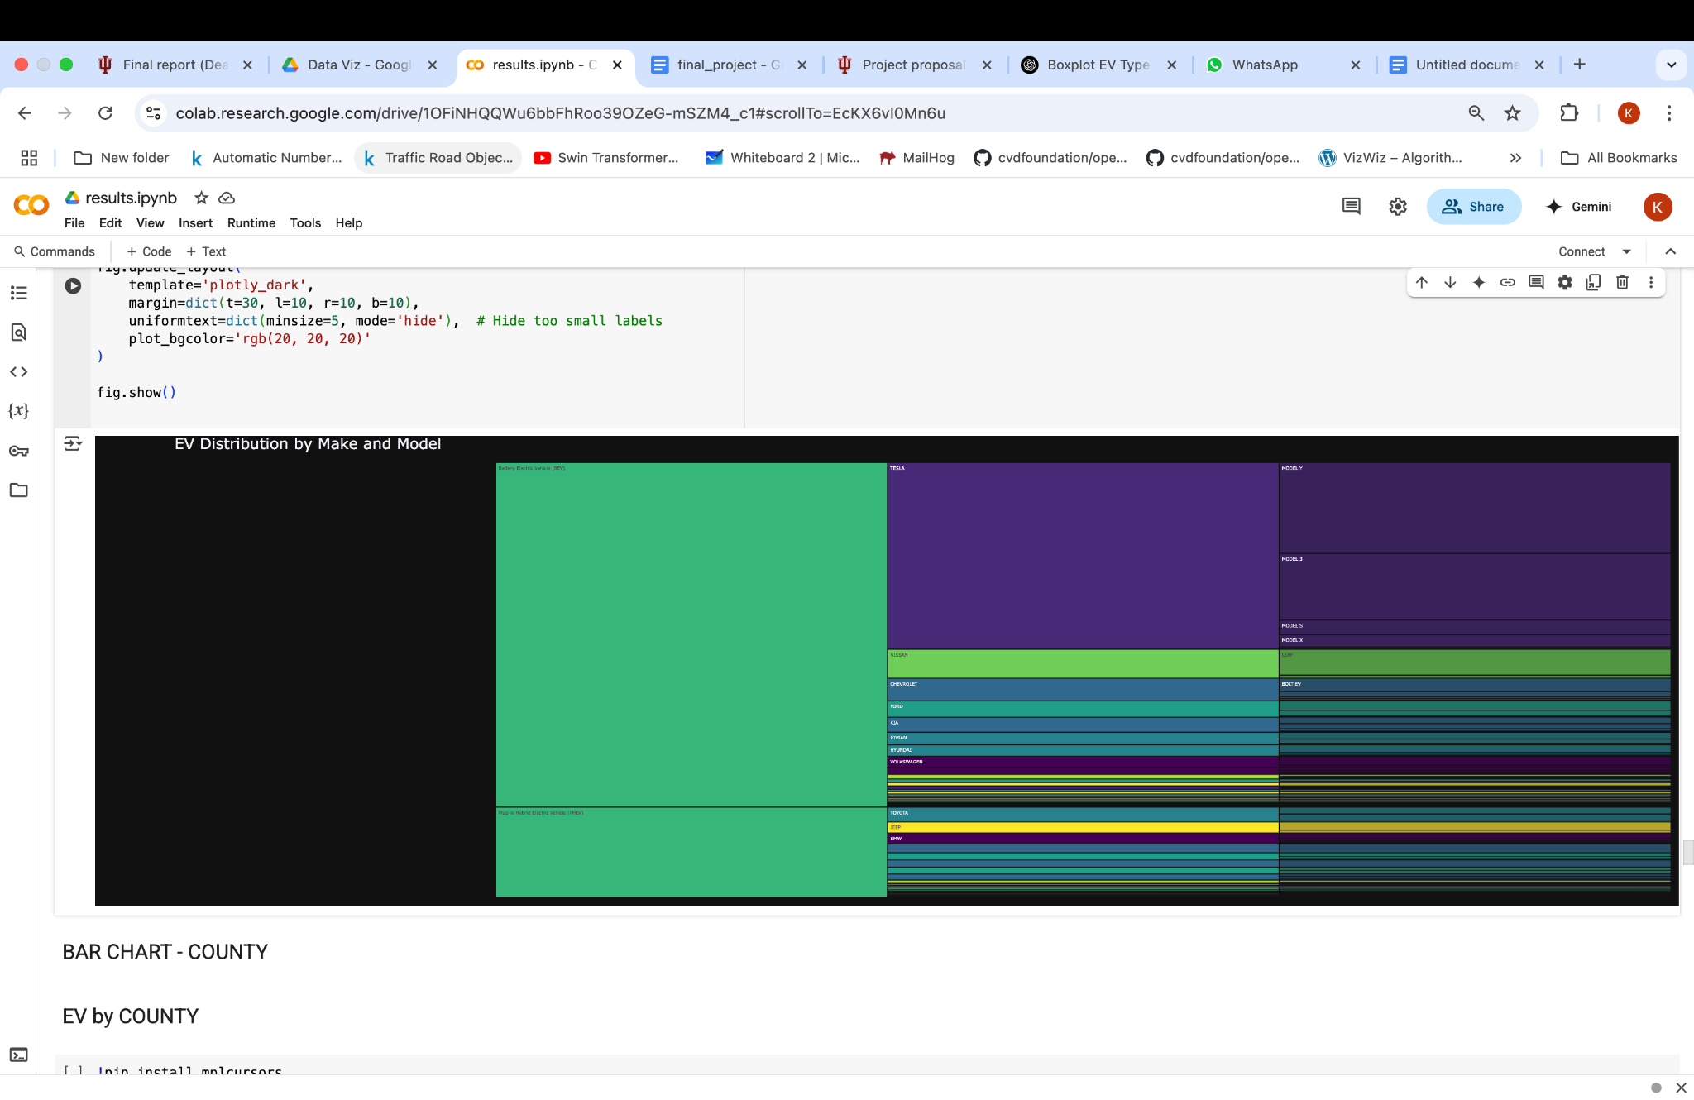

**2. EV Distribution by Make and Model using sankey diagram**

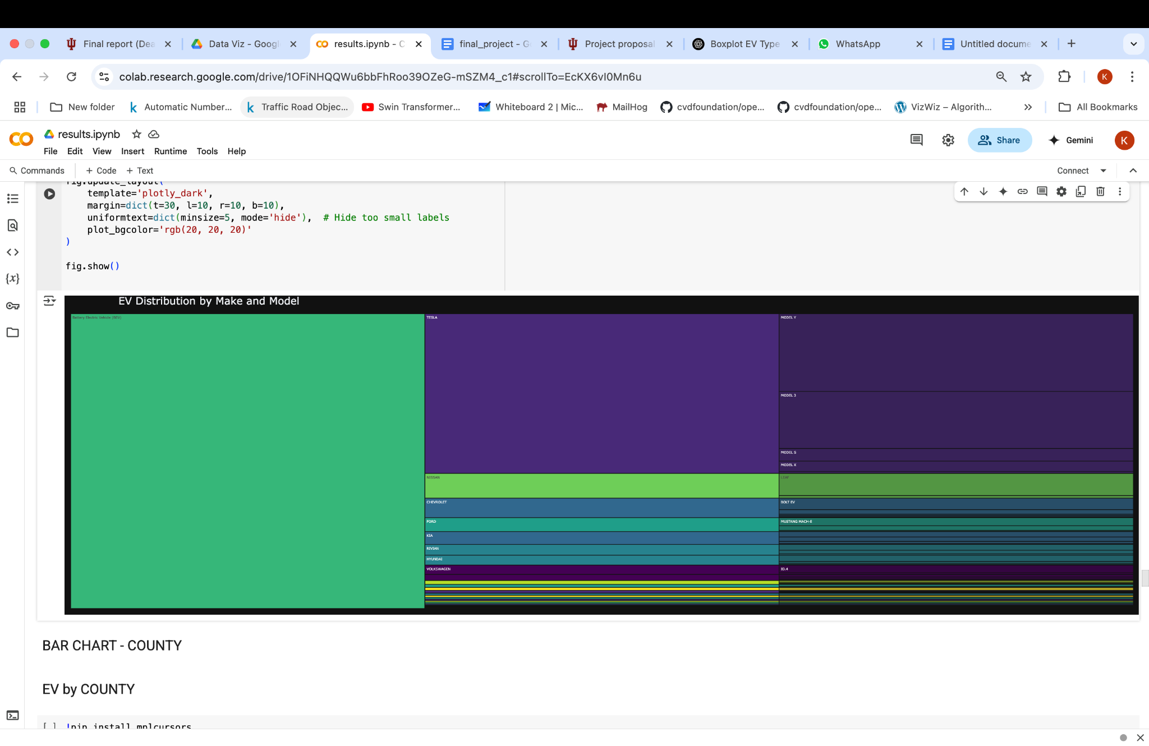

The goal of this visualization is to analyze the hierarchical distribution of electric vehicles (EVs) across different levels: from broad vehicle types (e.g., Battery Electric, Plug-in Hybrid) down to manufacturers (makes) and their respective models. This hierarchical flow helps uncover:

* How EV types are distributed across different automakers.
* Which makes dominate specific EV types.
* The most popular models within each make.

Such a layered breakdown is especially useful for identifying market leaders, understanding diversification within EV categories, and informing industry strategies or policy decisions around EV adoption.

**Advantages:**

* **Clear Hierarchical Visualization:** Icicle charts effectively break down categorical hierarchies, allowing users to drill down from broad EV types to specific makes and models.
* It also considers electric vehicle type which is lacking in sunburst.
* **Space-Efficient Layout:** Compared to Sankey diagrams, icicle charts use a compact vertical or horizontal format, making them cleaner for datasets with many branches.
* **Interactive Exploration:** Viewers can interactively expand or collapse levels, making it easier to focus on specific areas of interest without losing overall context.
* **Color Coded by Make:** Differentiating each make by color helps quickly identify which manufacturers have the widest model range within each EV type.

**Disadvantages:**

* **Label Overlap in Dense Categories:** When the number of models is large (especially within popular makes), labels can become too small or hidden, making parts of the chart harder to interpret.
* **Does Not Show Flow or Volume Transition:** While counts are encoded via block sizes, icicle charts don’t visually show flows like Sankey diagrams, which might limit understanding of volume movement between categories.

**Improvements:**

* **Focus on Top Makes:** For larger datasets, applying a filter to include only the top N makes can further improve interpretability by reducing node density and emphasizing the most impactful categories.

**3. Electric Vehicle Flow: Type to Make to Model (Top 10 Makes)**

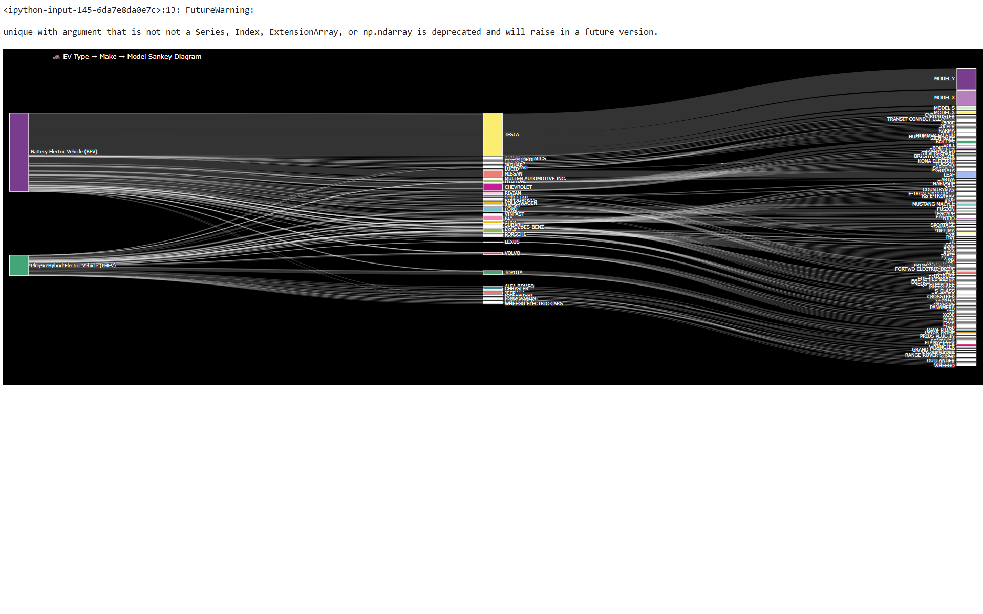

The goal of this visualization is to analyze the flow of electric vehicles (EVs) from broad vehicle type categories down to their respective makes and models. By visualizing this hierarchical relationship, we aim to better understand:

* How different EV types (e.g., Battery Electric, Plug-in Hybrid) are distributed across manufacturers,
* Which makes it dominate certain EV types.
* And which specific models are most popular under each make.

Such insights are valuable for industry trend analysis, market strategy, and policymaking related to electric vehicle adoption.

**Advantages:**

* **Easily Visualizes Hierarchical Flows:** The Sankey diagram clearly maps the transition from broad vehicle types to specific makes and models, making it easy to follow how categories break down step-by-step.
* **Quantifies Volumes at Each Stage:** The width of each flow visually encodes the magnitude (count), allowing viewers to quickly assess the size of different groups without needing to read exact numbers.
* **Highlights Branching Relationships:** By branching from a single source to multiple targets (Type ➔ Make ➔ Model), the diagram captures how diverse or concentrated certain categories are.
* **Ideal for Stepwise Comparisons:** Sankey diagrams are particularly effective when comparing volumes that need to be preserved across multiple levels, maintaining both context and proportion between layers.

**Disadvantages** :

### **Overlapping Nodes and Links:** Initially, when plotting the Sankey diagram using the default arrangement = 'perpendicular', we observed significant overlapping of nodes and links. The large number of Makes and Models caused congestion, making it hard to trace individual flows.

### **Solution: Adjust Arrangement and Layout**

To address this, the arrangement was switched to 'snap', which allowed nodes to self-adjust and align better, minimizing forced perpendicular connections. Additionally, node padding was increased, and the overall diagram size was enlarged to create more space between nodes. While these steps improved readability, they did not fully eliminate visual clutter.

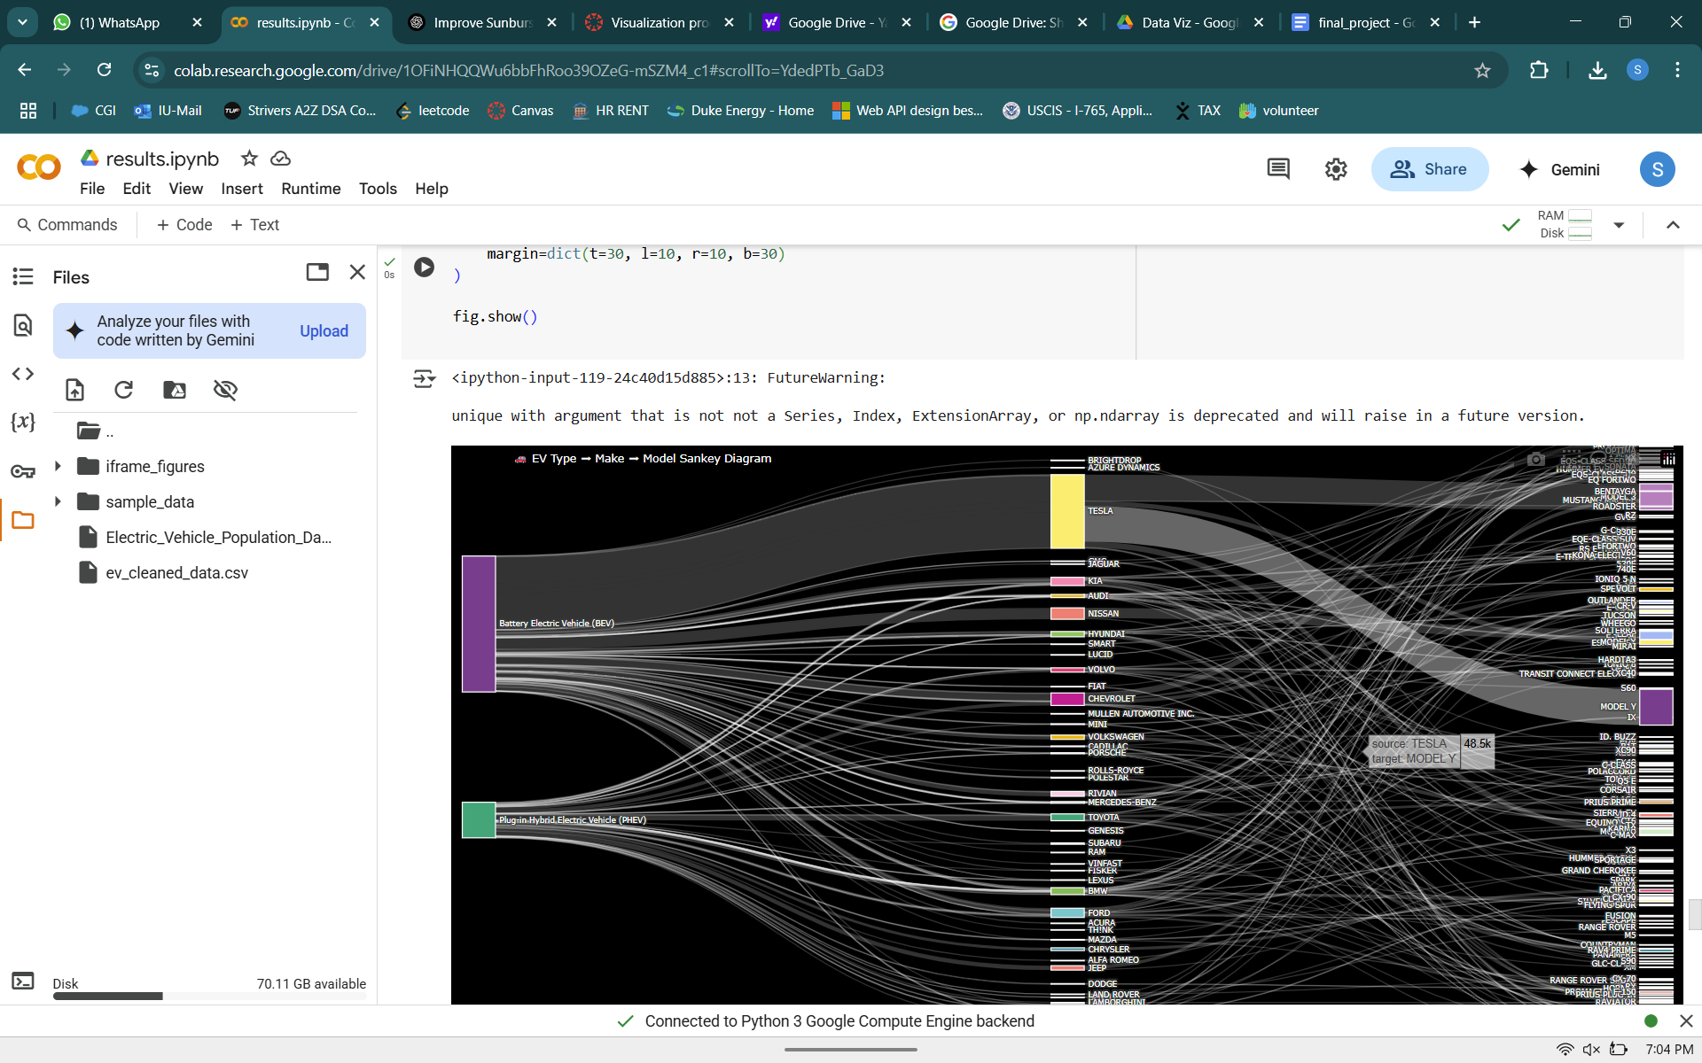

### 

### 

### 

### **Too Many Unique Nodes (Makes and Models)**

Despite layout improvements, the diagram remained visually busy because of the sheer number of unique vehicle makes and models. Even with better spacing, viewers had difficulty following the smaller, less significant flows.

### **Solution : Filtering Top N Makes**

To solve this, a filtering strategy was applied where only the Top N Makes (e.g., Top 10 by count) were selected. This drastically reduced the number of nodes and links, making the Sankey diagram cleaner and more interpretable.

Selecting Top N makes is justified because:

* The Top N makes account for the majority of the dataset volume,
* It preserves core market trends, it removes noise from rarely occurring makes and models, improves user experience without sacrificing analytical depth.

Thus, filtering made the visualization significantly more focused and effective.

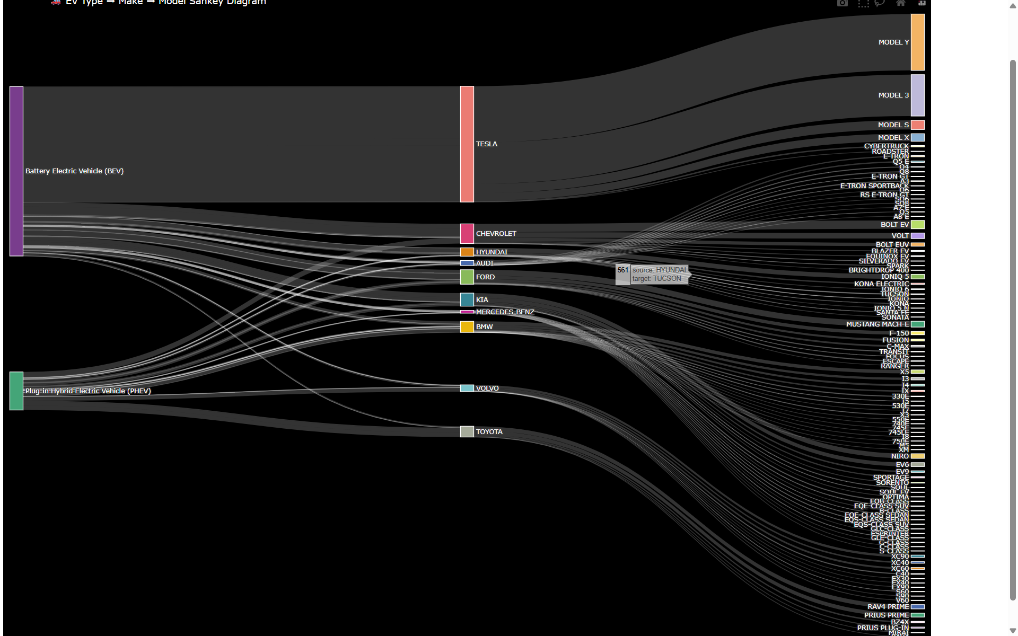

**D. How characteristics of EVs like base price and electric range impact adoption rate across washington.**

1. **Base MSRP across EV** 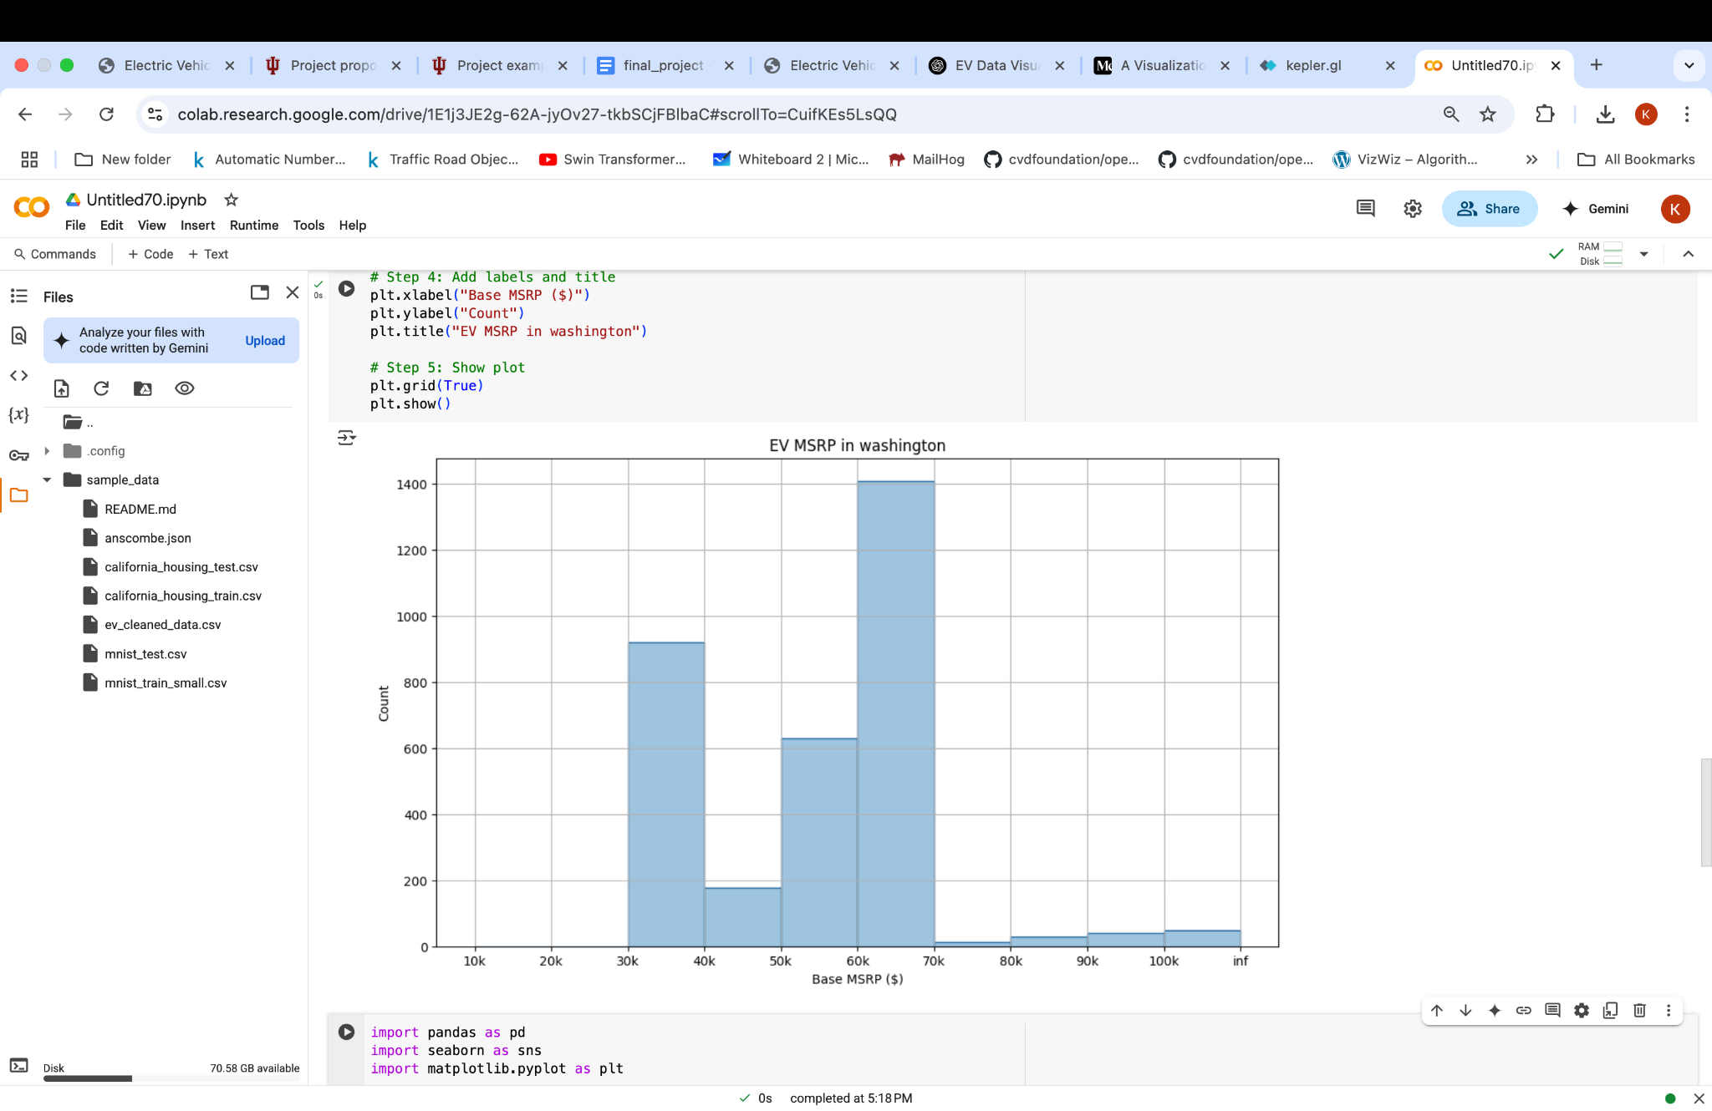

This histogram shows the distribution of electric vehicles (EVs) based on their Manufacturer's Suggested Retail Price (MSRP) in dollars. The x-axis represents the base MSRP in price bins (e.g., $10k–$20k, $20k–$30k, etc.), while the y-axis indicates the count of vehicles within each price range. The majority of EVs fall between the $30,000–$70,000 range, with the highest concentration around the $60,000–$70,000 bracket. A smaller number of vehicles are either lower-cost (under $30,000) or very high-end (over $70,000). The bin 100k to inf means the frequency of vehicles 100k MSRP and above. High frequencies are noticed in the range 30-40k and 50-70k inferring that people prefer medium cost vehicles over luxury ones. This histogram gives a clear overview of the price distribution, helping to illustrate the affordability or luxury positioning of EVs in Washington State.

### **Advantages:**

* **Gives Insight Into Pricing Trends:** It effectively shows that most EVs in Washington cluster in the mid-to-upper price range, which could suggest affordability challenges or market preferences.

### **Disadvantages:**

* **Bin Ranges Could Hide Details:** Grouping prices into broad bins may obscure finer price trends or variations between popular models.

**2. Base MSRP Comparison by Electric Vehicle Type**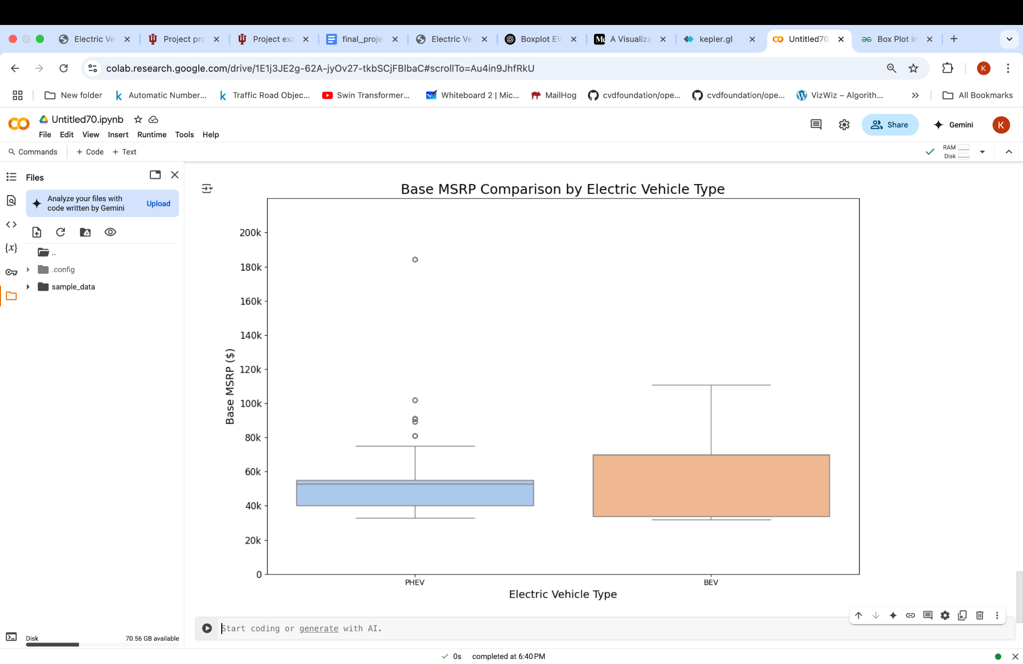

This box plot "Base MSRP Comparison by Electric Vehicle Type" compares the base Manufacturer's Suggested Retail Price (MSRP) between the two types of electric vehicles: PHEVs (Plug-in Hybrid Electric Vehicles) and BEVs (Battery Electric Vehicles). The x-axis distinguishes the two vehicle types (PHEV and BEV), while the y-axis represents base MSRP in dollars. Each box shows the interquartile range (IQR), the median, and any outliers. The plot indicates that BEVs generally have a wider price range and higher prices compared to PHEVs, with more extreme outliers above $100,000, whereas PHEVs are more tightly clustered around the lower price ranges. This visualization provides a statistical summary of price differences between the two EV categories.

### **Advantages:**

* **Good Summary of Price Distribution:** The box plot quickly shows the median, range, and outliers for each EV type, making differences between BEVs and PHEVs easy to compare.
* **Highlights Outliers Clearly:** Outliers (very expensive vehicles) are immediately visible, showing the variation within the EV market.

### **Disadvantages:**

* **Less Intuitive for Some Audiences:** If the audience is not familiar with box plots, they might find it harder to interpret compared to a bar or line chart.
* **Does Not Show Vehicle Counts:** While it summarizes price spread well, it does not convey how many vehicles exist at each price point within each category.

**3. Electric Range depending on the EV type**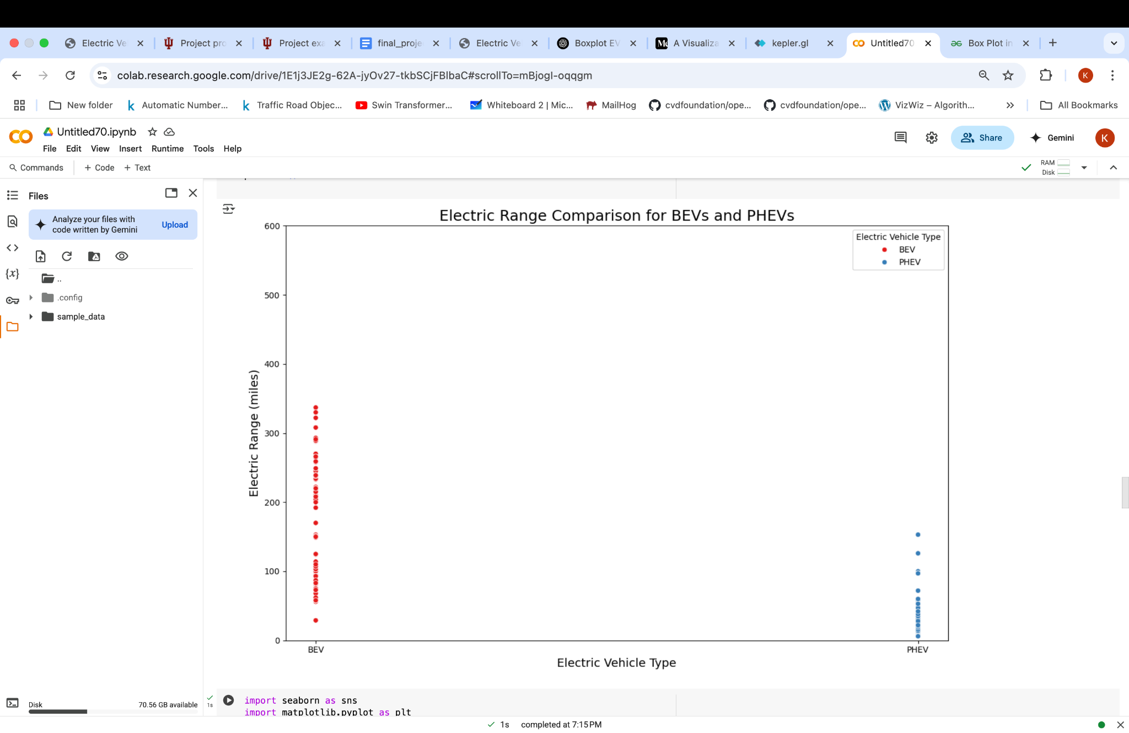

This scatter plot compares the electric driving range (in miles) of Battery Electric Vehicles (BEVs) and Plug-in Hybrid Electric Vehicles (PHEVs). The x-axis categorizes the vehicle types into two groups: BEV and PHEV. The y-axis shows the electric range, ranging from 0 to 600 miles. Each point represents a specific vehicle model. BEVs are plotted in red, and PHEVs are plotted in blue, as indicated in the legend. The plot shows that BEVs have a much wider spread in their electric range, with many BEVs reaching above 200 miles, some even exceeding 400 miles. In contrast, PHEVs mostly cluster at much lower electric ranges (typically under 50 miles), highlighting the fundamental difference between the two vehicle types in terms of their design and purpose. This visualization effectively communicates the performance gap between BEVs and PHEVs when considering pure electric driving capability.

### **Advantages:**

* **Highlights the Key Range Difference:** The scatter plot very clearly shows that BEVs generally have a much higher electric range compared to PHEVs, making the fundamental distinction obvious.

### **Disadvantages:**

* **Data Overlap in PHEV Category:** Since most PHEVs have similar low ranges, the points overlap heavily, making it difficult to see individual values without zooming or jittering the points slightly.
* **Does Not Show Average or Median Values:** The scatter plot shows all individual points but doesn't summarize the data (e.g., with a mean or median line), which might make it harder for viewers to grasp typical ranges at a glance.

**4. Electric Range Comparison by Electric Vehicle Type**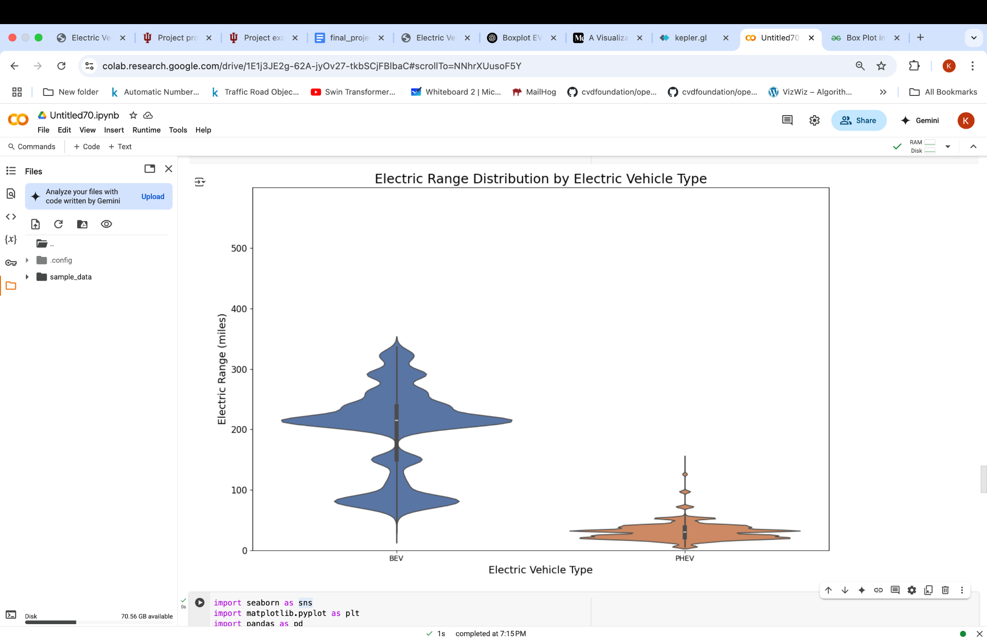

This visualization is a violin plot that displays the distribution of electric driving ranges for two categories of vehicles: BEVs and PHEVs. The x-axis shows the two vehicle types, and the y-axis shows the electric range in miles. The shape of each violin plot represents the distribution density. Wider sections indicate a higher concentration of vehicles at that range. Inside each violin is a box plot, which shows the median, interquartile range (IQR), and outliers.

* **BEVs** generally offer higher ranges, with most models clustered between 200 and 300 miles, and some extending up to 500 miles.
* **PHEVs** have a much narrower and lower range distribution, mostly under 50 miles, with very few exceptions.

### **Advantages:**

* **Rich Representation of Distribution:** The violin plot combines the benefits of a box plot and a density plot, showing not just central tendency and spread, but also the shape of the data distribution.
* **Strong Visual Comparison:** The contrast in shape and scale between BEVs and PHEVs clearly communicates the performance gap in electric range.

### **Disadvantages:**

* **Overly Smooth Appearance Might Obscure Discrete Gaps:** Kernel density estimation smooths out the shape, which might hide distinct clusters or groupings of specific model ranges.

**E. How is Electric Range related to Base MSRP?**

1. **Box plot for electric range by base msrp**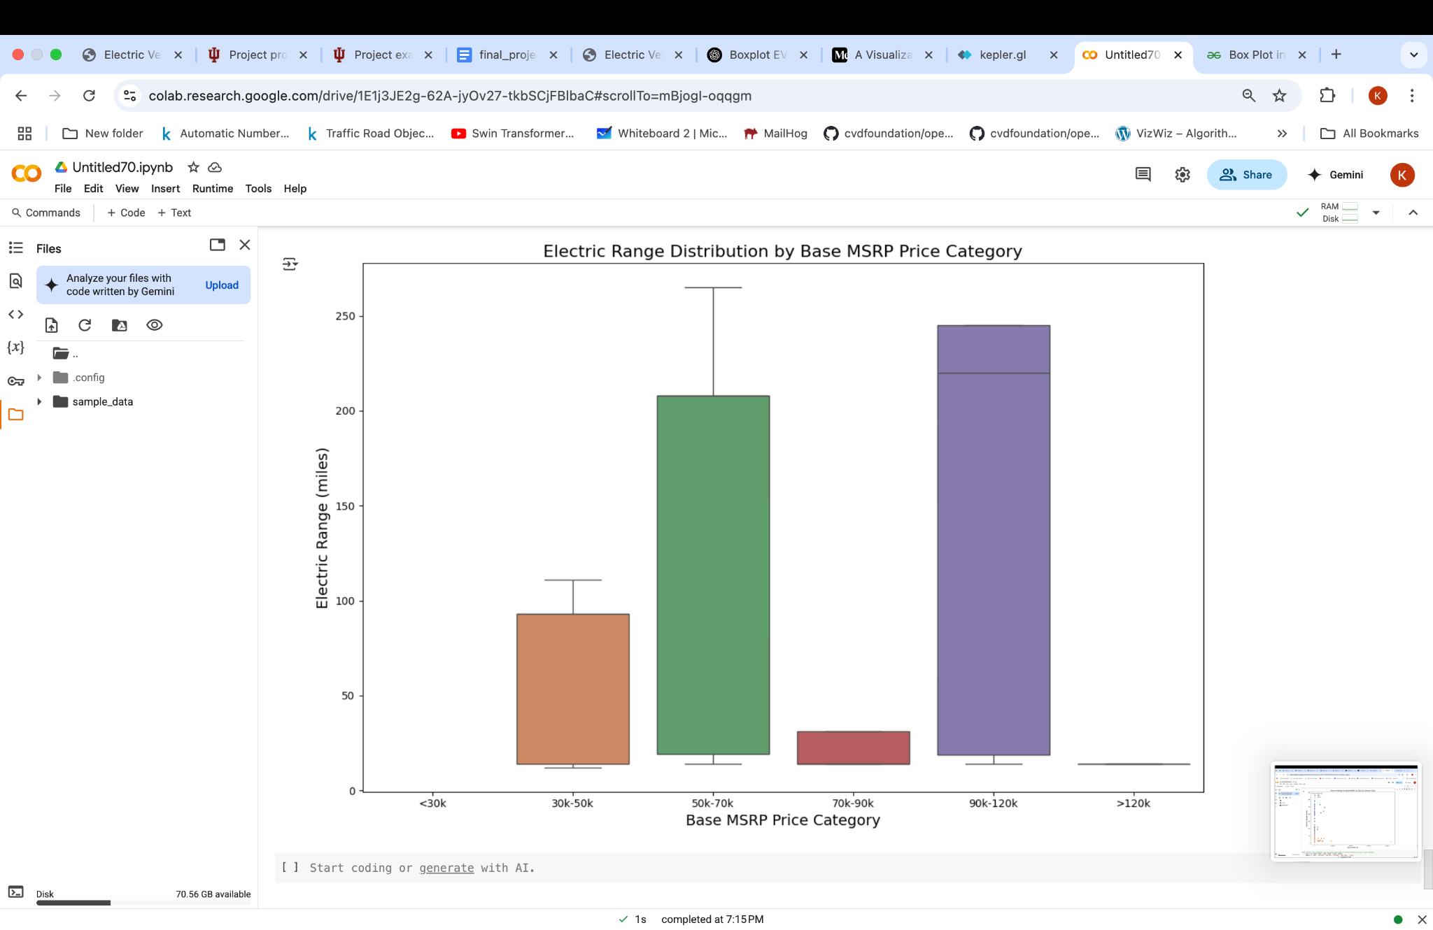

This bar plot presents how the electric driving range (in miles) varies across different vehicle price categories. The x-axis categorizes EVs into MSRP ranges. The y-axis indicates the average electric range. From the chart:

* Vehicles in the **50k–70k** and **90k–120k** categories have the **highest average ranges**, both around or above **200 miles**.
* The **<30k** and **70k–90k** groups show noticeably **lower ranges**.
* Interestingly, the **>120k** category has **very low average range**, which may be due to luxury or specialty vehicles that do not prioritize range.

This visualization provides a deeper look at how vehicle cost (MSRP) is related to functional performance (range), revealing that higher price does not always guarantee better range.

### **Advantages:**

* **Clarifies Price-to-Performance Patterns**: It helps uncover trends and anomalies across price brackets such as the unexpectedly low range in the >$120k category.

**Disadvantages:**

* **No Information About Count per Category**: Without knowing how many vehicles fall into each price bin, it’s hard to assess how reliable or representative each average is.

**F. How is CAFV eligibility compared for different EV models and counties ?**

**1.Stacked Bar chart for CAFV**

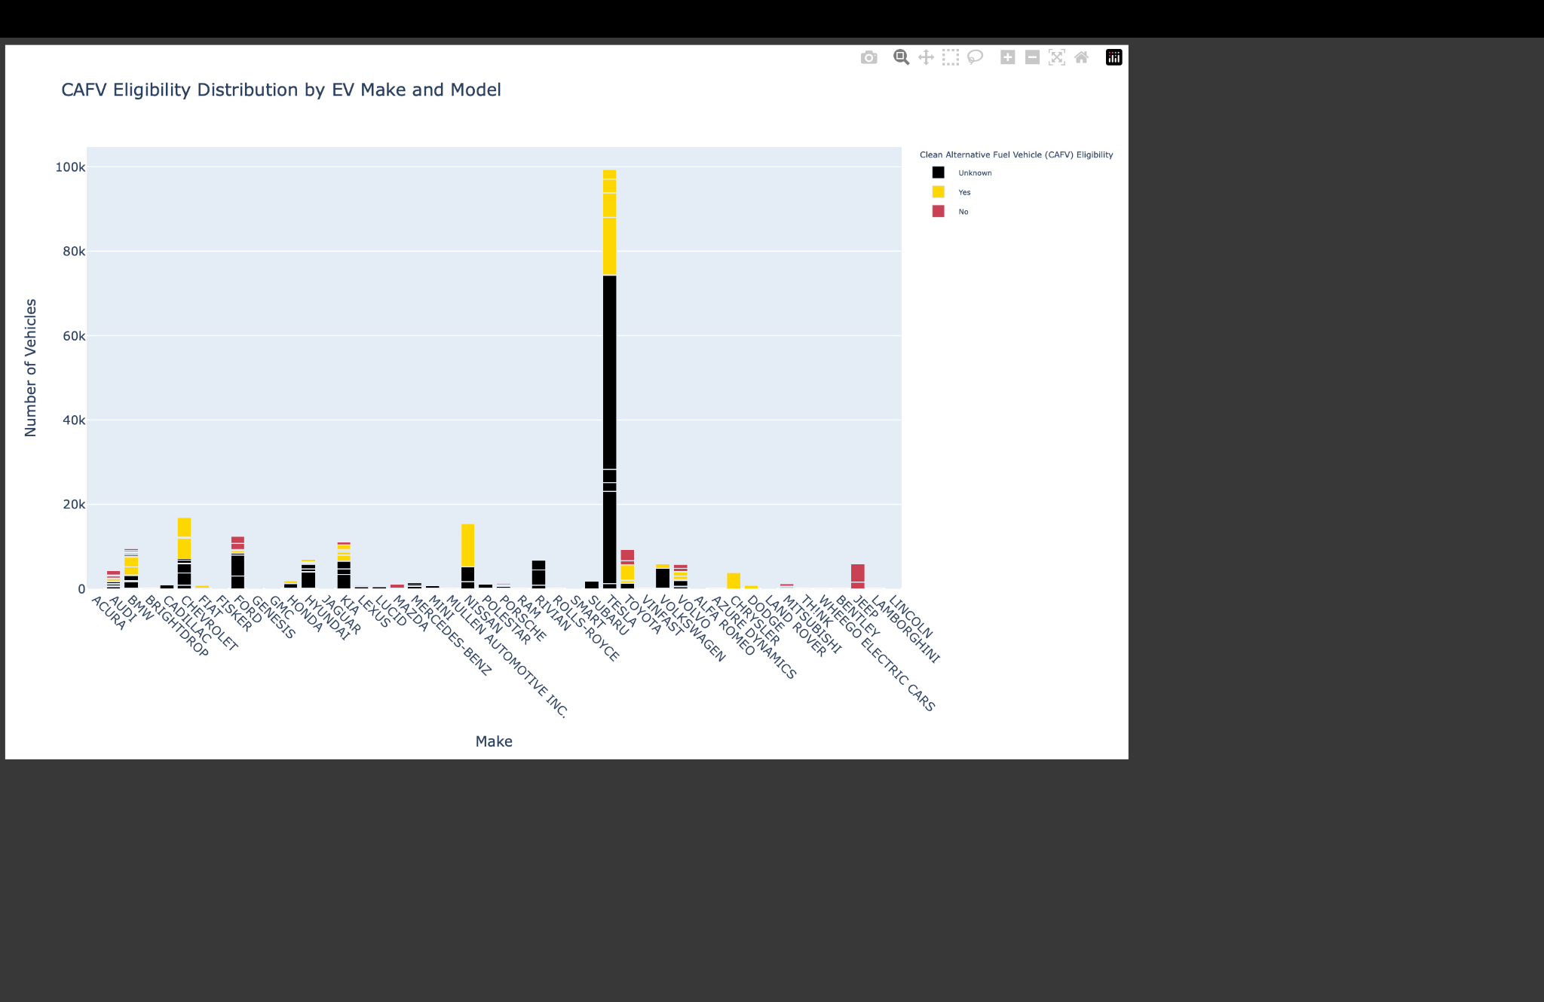

This stacked bar chart visualizes the Clean Alternative Fuel Vehicle (CAFV) eligibility status for various EV makes and models. Each model is represented by a bar segmented by eligibility categories: Yes, No, and Unknown. The graph allows viewers to compare how different manufacturers and models align with clean fuel standards based on aggregated count data. This helps to assess compliance with clean fuel standards across manufacturers and subsidies, or rebates based on vehicle eligibility trends.

### **Advantages:**

1. **Detailed Model-Level Insight**: Clearly highlights how individual EV models compare in terms of eligibility, making it easier to assess compliance with clean fuel standards across manufacturers.
2. **Supports Strategic Planning**: Provides valuable data for policymakers, utility providers, and incentive program designers to target outreach, subsidies, or rebates based on vehicle eligibility trends.

### **Disadvantages**

1. **Visual Overload with Many Models:** When too many models are included, the chart can become crowded and harder to read, reducing its overall effectiveness for quick insights.
2. **Limited Context Without Sales Data:** The chart shows raw eligibility counts but does not account for broader market impact or popularity, which may skew interpretation if not contextualized.

**2. Choropleth map for CAFV Eligibility % by County**

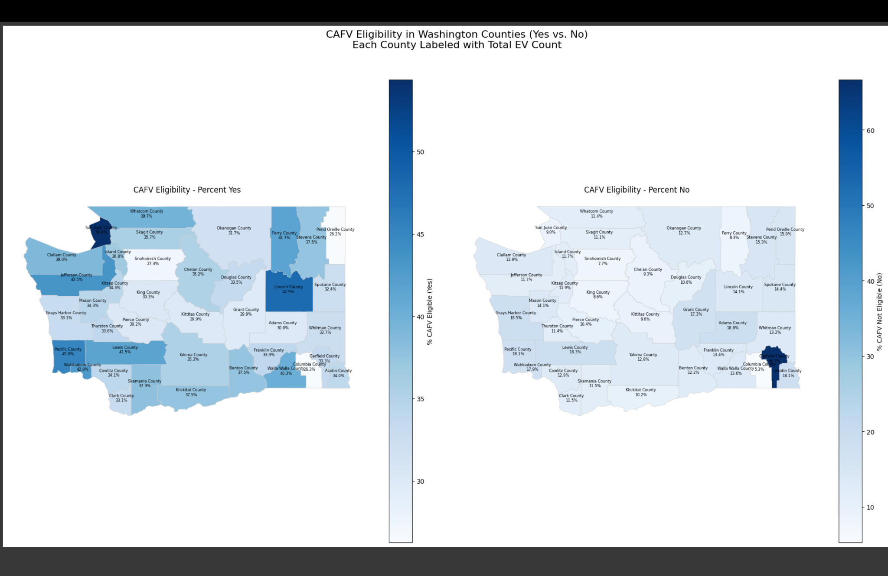

This visualization presents two side-by-side choropleth maps of Washington State, where each county is shaded based on the percentage of electric vehicles classified as either CAFV Eligible (Yes) or Not Eligible (No). The maps use a single-color intensity scale to reflect the relative concentration of each category across counties, and labels display total vehicle counts for added context. This helps decision-makers prioritize regions for EV incentives, charging infrastructure, or public outreach based on eligibility saturation and vehicle volume.

**Advantages:**

1. **Geographic Clarity at a Glance:** Enables easy identification of regional disparities in clean vehicle adoption, highlighting counties with strong or weak alignment to CAFV standards.
2. **Useful for Policy and Infrastructure Planning:** Helps decision-makers prioritize regions for EV incentives, charging infrastructure, or public outreach based on eligibility saturation and vehicle volume.

### **Disadvantages**

1. **Population Bias Risk:** Heavily populated counties may dominate visually, which can overshadow trends in smaller regions if not normalized or paired with per-capita data.
2. **Static Comparison Only:** While useful for side-by-side viewing, these maps don’t capture trends over time or shifts in eligibility, requiring additional analysis for temporal insights.

**Discussion And Conclusion:**

The project offers a comprehensive analysis of electric vehicle (EV) trends, focusing on adoption patterns, geographic influences, and the popularity of different manufacturers. In addition to capturing temporal dynamics, the study explores policy alignment through CAFV incentive eligibility and technical attributes such as base price and electric range. The visualizations enhance interpretability, offering insights into both systemic factors and consumer behavior across time and space.

**Insights and Effectiveness:**

1. **Temporal Patterns**

● The **Animated EV Adoption Over Time by Make** area chart reveals clear growth patterns among top manufacturers, showcasing how certain brands like Tesla and Chevrolet have gained popularity over the years. The animation element makes this visualization especially effective in illustrating year-over-year momentum and shifts in market dominance.  
● The **EV Count by Model Year** line chart provides an overview of registration patterns over time, identifying key adoption periods, possibly in response to policy incentives or infrastructure expansions. This temporal insight helps contextualize the impact of statewide regulations.

### **Geographic Insights**

### ● The **CAFV Eligibility Choropleth Maps** (Yes vs No) display the spatial distribution of clean vehicle eligibility across Washington counties. These maps are effective in highlighting regional disparities and helping policymakers target areas with lower eligibility for focused outreach or infrastructure support. ● The **EV Count by County Bar Chart** identifies the top counties by electric vehicle registrations, offering a quick comparison across regions. Annotated totals and sorting by rank enhance interpretability, especially for policy and utility planning.

### **Policy & Technical Characteristics**

● The **CAFV Eligibility by Make and Model** stacked bar chart visualizes how eligibility varies by vehicle brand and model. It is particularly useful for understanding compliance at the manufacturer level and helps reveal trends where eligibility may be lacking despite EV classification.  
● The **Pie Chart of CAFV Eligibility** offers a high-level snapshot of the dataset’s distribution across eligibility statuses. Its simplicity supports quick communication of proportions and acts as a helpful summary for broader audiences.

### **Interactive Exploration**

● Tools such as **Kepler.gl maps** allow users to explore EV adoption spatially with greater depth enabling pan, zoom, and filter interactions at the county level. These enhance geographic understanding and allow stakeholders to focus on specific regions of interest.  
● Interactive visualizations built with **Plotly** such as stacked bar charts and animated timelines offer hover tooltips, filters, and animation frames that enrich the user experience. These features help both technical and non-technical users engage with the data more intuitively and explore patterns dynamically.

**Limitations and Caveats:**

1. **Data Completeness**

Several parts of the analysis are impacted by missing or incomplete data, particularly in key fields such as CAFV eligibility, electric range, and base MSRP. A significant number of records list CAFV eligibility as “unknown due to low battery range,” which introduces skewness and limits the reliability of certain interpretations. Some visualizations, like the correlation matrix, revealed weak or negligible relationships limiting the strength of inferences drawn from certain variable**s.**

1. **Static vs. Interactive Visualizations**

While static charts (e.g., line and bar graphs) effectively communicate high-level trends, interactive tools such as Kepler.gl offer deeper spatial insights. However, these interactive platforms may require additional technical proficiency to fully leverage their capabilities.

1. **Normalized Data :**

County-level insights may be skewed due to the absence of population normalization. Without accounting for the number of residents or vehicles per capita, high EV adoption in densely populated counties may overshadow meaningful trends in smaller or rural regions, limiting the fairness of regional comparisons.

**Summary:**

This project presents a comprehensive exploration of electric vehicle (EV) adoption trends across Washington State, with a particular focus on Clean Alternative Fuel Vehicle (CAFV) eligibility, manufacturer popularity, and regional and temporal dynamics. Using a combination of static and interactive visualizations, the analysis uncovers patterns in EV distribution, policy alignment, and vehicle characteristics such as base MSRP and electric range.

Key visualizations include animated time series charts tracking top manufacturers over time, choropleth maps highlighting county-level eligibility patterns, and stacked bar charts that compare eligibility status across makes and models. Additional tools like Folium and Kepler.gl enable deeper geographic insights, while pie charts and correlation matrices provide high-level summaries and relationships between variables.

The project also identifies important limitations, including data gaps in eligibility and range fields, inconsistent categorical labeling, and a lack of population-normalized geographic analysis, which may introduce skewed interpretations. Despite these, the study provides actionable insights for policymakers, utility providers, and manufacturers, supporting targeted interventions and more equitable clean vehicle adoption strategies.

In summary, this project blends data visualization, policy analysis, and technical vehicle attributes to provide a multi-dimensional view of EV trends, offering a foundation for future studies and data-driven transportation planning.

**VI. FUTURE WORK AND RECOMMENDATIONS**

While this project offers valuable insights into EV adoption trends and CAFV eligibility across Washington State, several areas remain open for deeper exploration. Enhancing data granularity, integrating demographic factors, and incorporating infrastructure readiness can improve the quality and equity of future analyses. Additionally, predictive modeling could support planning efforts under various policy scenarios.

**Population-Normalized Adoption Metrics**Incorporating population or vehicle registration data at the county level would allow for per-capita EV adoption analysis, helping reveal true regional disparities beyond raw counts.

**Demographic Integration**Linking EV data with demographic indicators such as income, education, and urban-rural classification can support more targeted, equitable policy interventions.

**Infrastructure Readiness Assessment**Including data on charging station availability, electric utility coverage, and grid capacity would help assess regional readiness to support increased EV demand.

**Temporal Forecasting**By leveraging historical trends in model year registration, eligibility rates, and manufacturer growth, the project could be extended to predict future EV adoption patterns under different policy or incentive scenarios.

**VII. References:**

1. <https://catalog.data.gov/dataset/electric-vehicle-population-data>
2. <https://www.nbcnews.com/news/us-news/washington-state-plans-ban-non-electric-vehicles-2030-rcna21683>
3. <https://www.columbian.com/news/2025/apr/17/washington-has-distance-to-make-up-to-reach-electric-vehicles-goal/>
4. <https://www.kaggle.com/code/harshitraizada/complete-eda>
5. <https://medium.com/@yingzhencao/a-visualization-of-electric-vehicle-population-in-washington-state-united-states-7c53384bbbed>
6. [https://ieeexplore.ieee.org/abstract/document/9101928/authors#author](https://ieeexplore.ieee.org/abstract/document/9101928/authors#authors)
7. <https://www.ewadirect.com/proceedings/aemps/article/view/8182/pdf#:~:text=with%20data%20from%20Experian%20Information,Battery%20electric%20vehicles>